Joshua0611

**HDB RESALE PRICE ANALYSIS WITH ENSEMBLE LEARNING TECHNIQUES**

Table of Contents

HDB RESALE PRICE ANALYSIS WITH ENSEMBLE LEARNING TECHNIQUES 3

EXECUTIVE SUMMARY 3

INTRODUCTION 3

DATA COLLECTION, PREPROCESSING AND FEATURE ENGINEERING 4

METHODOLOGY 5

RESULTS AND ANALYSIS (GENERAL) 7

RESULTS AND ANALYSIS (CATEGORICAL PIPELINE) 8

RESULTS AND ANALYSIS (NUMERICAL PIPELINE) 10

RESULTS AND ANALYSIS (LEASE START PIPELINE) 18

RESULTS AND ANALYSIS (SALE DATE PIPELINE) 20

RESULTS AND ANALYSIS (META PIPELINE) 21

LIMITATIONS 24

CONCLUSION 26

RECOMMENDATIONS 26

REFERENCES 27

ACKNOWLEDGEMENTS 27

CONTACT INFORMATION 27

ANNEXES 27

ANNEX A: LOWER-LEVEL MODEL ARCHITECTURE 1

HIGH-LEVEL OVERVIEW OF MODEL ARCHITECTURE 1

GENERAL PRE-PROCESSING 2

CATEGORICAL PIPELINE 3

NUMERICAL PIPELINE 4

TIME SERIES PIPELINES 5

META PIPELINE 7

ANNEX B: ADDITIONAL VISUALISATIONS GENERATED FROM THE CATEGORICAL PIPEINE 1

ANNEX C: ADDITIONAL VISUALISATIONS GENERATED FROM THE NUMERICAL PIPEINE 1

REFERENCES 1

# HDB RESALE PRICE ANALYSIS WITH ENSEMBLE LEARNING TECHNIQUES

EXECUTIVE SUMMARY

1. The HDB Resale Flat price analysis with ensemble learning techniques project (henceforth “The Project”) aims to utilise ensemble learning techniques to aid in an analysis of HDB resale flat prices (henceforth “Prices”), to help in decision making with regards to the sale and purchase of HDB resale flats.
2. In particular, the Project aims to determine the links between individual features of HDB flats and Prices, and how features from the same category work with one another to further boost or dampen Prices.
3. The key findings of this analysis include:
   1. The existence of numerous and varied links between HDB Resale flat features and Prices, with the relevance of the relationships discovered being dependent on the needs of the users of this study.
4. The following are the recommended follow up actions from this project:
   1. Given the nature of this project, no hard recommendations can be made regarding follow up actions that ought to be taken.
   2. Greater resources should be invested into the use of machine learning and AI for the purpose of data analysis for better decision making, due to its incredible potential for high returns.

INTRODUCTION

1. This report describes the analysis of the relationship between individual features of HDB flats and their resale prices, and how features from the same category work with one another to further boost or dampen them, generated using ensemble learning techniques.
2. This analysis was conducted to aid in consumers’ decision making regarding the buying and selling of HDB resale flats, through the provision of insights leveraging on ensemble learning technology, which from my understanding does not yet exist for the common Singaporean resident.
3. This analysis leveraged on machine learning as I was unable to find any such analysis that was publicly available. I therefore felt that utilising machine learning for this analysis would allow for the findings to be more valuable to readers, given the additional and unique perspective it would provide, given the relative novelty of such an analysis. It also leveraged on (white box) ensemble learning techniques to allow for the effective analysis of HDB flats’ features, which consisted of data of different types and could therefore not be analysed using a single machine learning model.

DATA COLLECTION, PREPROCESSING AND FEATURE ENGINEERING

1. The data utilised was sourced from public sources, as a set of .csv files. More information regarding the sources of the data utilised may be found in the REFERENCES section below.
2. The data regarding the features of the flats was grouped in this manner to aid in its use in training the ensemble learning model utilised (discussed below in the section “Methodology”):
   1. Categorical data:
      1. Flat type
      2. Flat model
      3. Town the flat was in
   2. Numerical data:
      1. The flat’s (estimated) floor
      2. The flat’s floor area
      3. The amount of lease left on that flat
   3. Time series data:
      1. The lease start date of that flat (year it was constructed)
      2. The sale date of that flat’s transaction
3. This data was then pre-processed, and underwent feature engineering, based on the data class it belonged to (Categorical, Numerical, or Time series), as listed below:
   1. Categorical features.
      1. All categorical features were first filtered, with data points with feature values from categorical feature classes that constitute less than 5% of the average number of occurrences of each class for that feature being truncated.
      2. The data then underwent one hot encoding and feature crossing.
   2. Numerical data.
      1. The numerical features and price underwent normalisation and feature crossing.
   3. Time series features.
      1. For the time series features, average prices corresponding to the time series value was mapped to the corresponding value.

* + 1. Though I would not consider this a form of preprocessing, it may be noted that the time series data was differenced before being fitted into the model utilised.

METHODOLOGY

1. The model utilised for this analysis is an ensemble machine learning model, composed of 4 base pipelines (1 for categorical data, 1 for numerical data, and 2 for time series data) feeding information into 1 Meta pipeline. This is illustrated in Figure 1 below.

Figure 1: Diagram illustrating high-level overview of the model architecture utilised

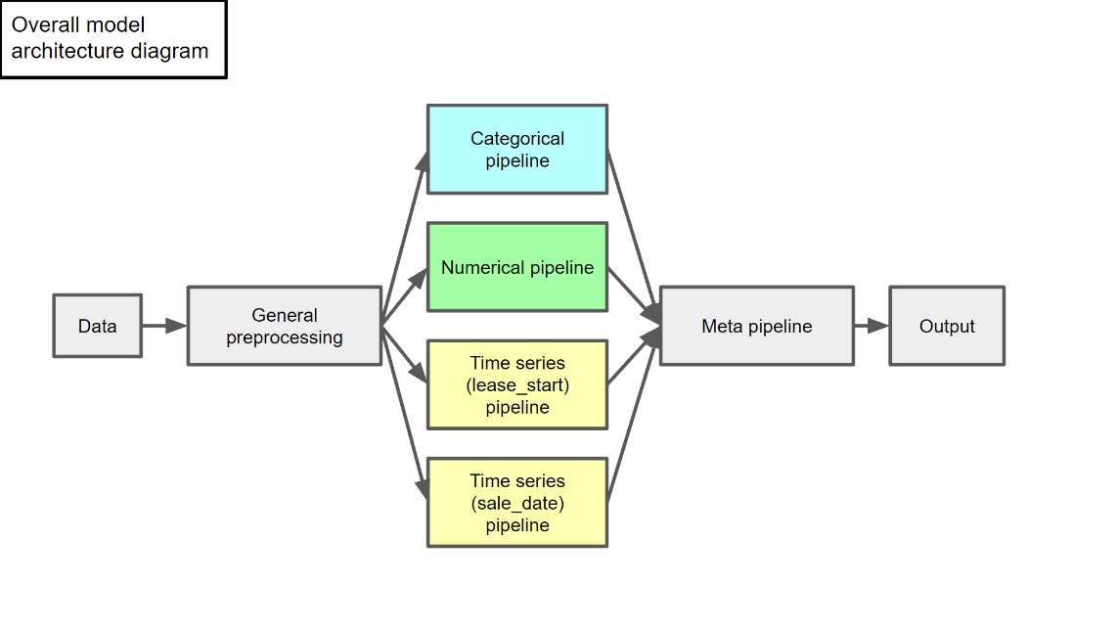

1. All the pipelines consisted of regression models and handled their own data type’s preprocessing and feature engineering as mentioned above. The model types used for each pipeline are as follows:
   1. Categorical pipeline. Multilinear ridge regression model with alpha=6.
   2. Numerical pipeline. Multilinear regression model.
   3. Time series pipeline (lease start). ARIMA(1, 1, 5) model.
   4. Time series pipeline (sale date). ARIMA(6, 1, 0) model.
   5. Meta pipeline. Stacking regressor utilising a multilinear regression model.
2. In general, the models were trained on 80-20 train-test splits corresponding to their data type.
3. However, the way the data was split differed for each pipeline, and are as follows:
   1. Categorical pipeline. The train-test split was generated by splitting the data in a stratified manner to allow for the occurrence of all categorical categories at equal proportions across the train and test sets, across each feature. This was to ensure that the model could fit and be evaluated in a manner that was representative of all categorical categories observed.
   2. Numerical and Meta pipelines. The train-test splits were generated by selecting data randomly, according to the pre-determined ratios of training and testing data as mentioned above.
   3. Time series pipelines. The train-test splits were generated in a manner like the numerical and Meta pipelines, before each data set underwent preprocessing and feature engineering as mentioned above.
4. Lastly, the models and model hyperparameters, for the Categorical, Numerical, and Meta pipelines were selected to optimise the 5-fold cross validation R2 scores of the models (this was done to optimise the models for explanatory power, to aid in this analysis[1]), while the Akaike Information Criterion (AIC) was used to tune the model hyperparameters for the models of the Time series pipelines, in conjunction with the Box–Jenkins method[2][3].
5. Additional information regarding the lower-level aspects of the model architecture may be found in ***Annex A***.

RESULTS AND ANALYSIS (GENERAL)

1. In general, all the base models and the ensemble models performed well. This is seen in the reported error values and metrics as shown below in Figure 2.

Figure 2: Model score reporting

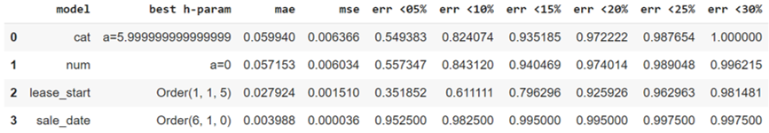

RESULTS AND ANALYSIS (CATEGORICAL PIPELINE)

1. Generally, it was found that flat type was the most impactful feature across all “raw” categorical features, with most model weights corresponding to this feature generally exceeding the model weights corresponding to all other features. This is barring 2 exceptions from the feature model type, which could therefore be said to be the next most impactful categorical feature, followed lastly by the town the flat was in. This distribution of model weights for the categorial pipeline’s model is illustrated in Figure 3 below.

Figure 3: Absolute model weights by raw feature, coloured by feature

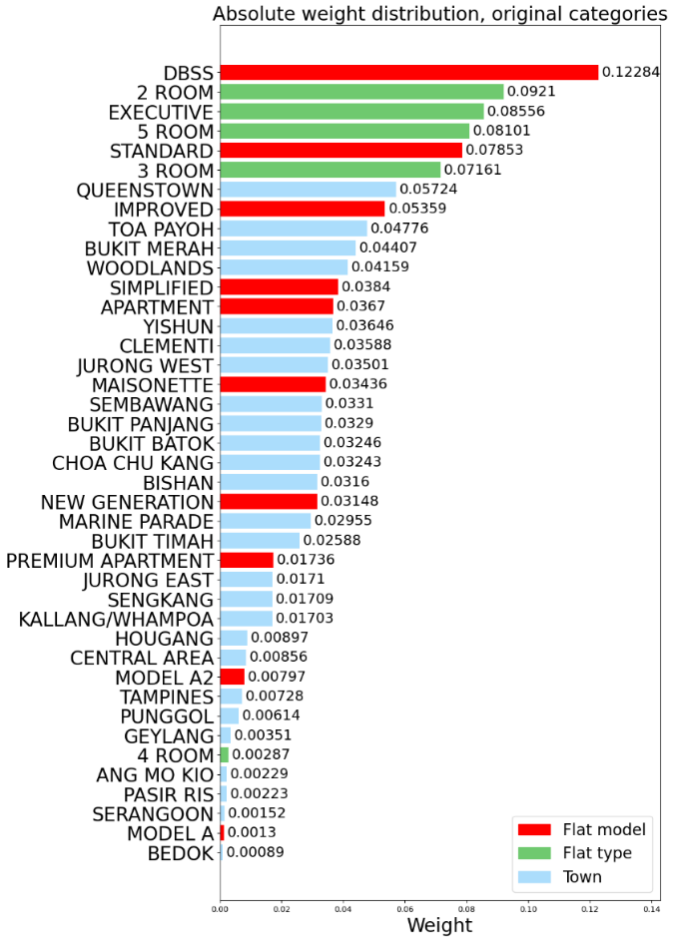

1. Furthermore, as shown in Figures 3 and 4 below, it was found that segments composed of features with positive impacts on prices tended to positively “boost” prices further, and vice versa. This implied a “bonus” boosting (positively or negatively) of prices for flats that had a greater number of categorical feature values that impacted prices in the same manner.
2. However, it was also found that segments composed of a mix of features that had positive and negative impacts on prices tended to have a direction of impact equal to the sign of the mean of the weights of the features it was composed of. This implied a “bonus” dampening of impacts of less impactful features, by features of flats that had greater impacts on Prices.
3. For example, based on the model weights, it may be said that the features DBSS, 5 ROOM, and 4 ROOM impacted Prices positively, positively, and negatively, to decreasing extents, as shown in Figure 4. However, based on the model weights as illustrated in Figure 5, it may be said that the feature crosses 5 ROOM DBSS and 4 ROOM DBSS both have positive impacts on Prices, based on Figure 5.

|  |  |
| --- | --- |
| Figure 4: Absolute model weights by raw feature, coloured by sign | Figure 5: Absolute model weights by segments (top 20) |

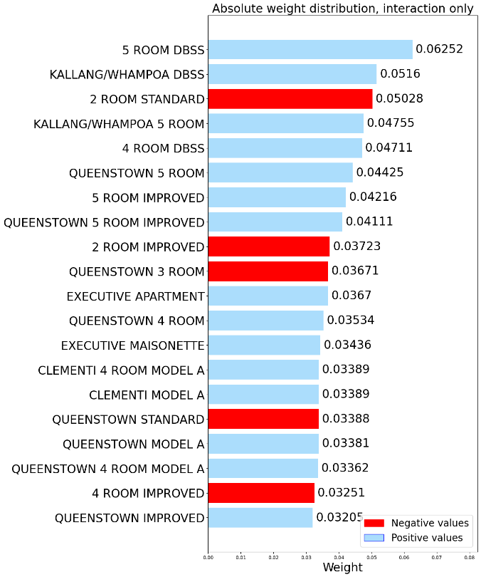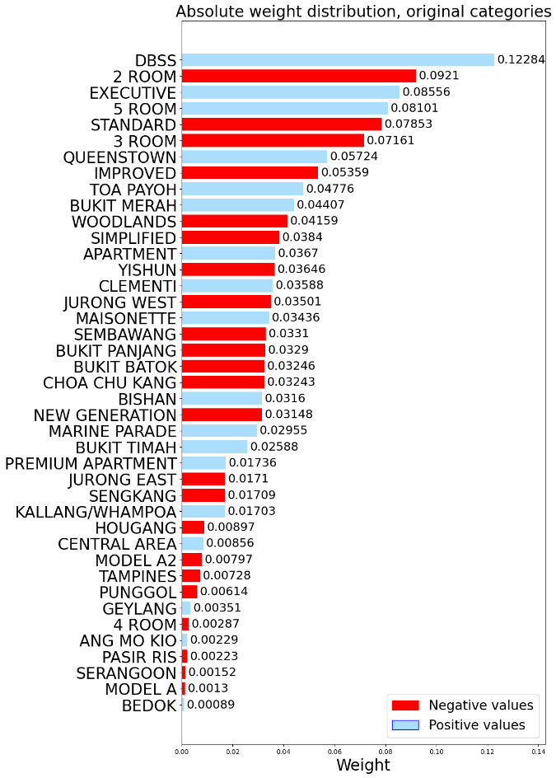

1. Additional analyses. In addition to the general observations mentioned above, further analysis of the relationships described may be done using the relevant visualisations attached in ***Annex B***.

RESULTS AND ANALYSIS (NUMERICAL PIPELINE)

1. In the case of the numerical features, however, it was found that each feature had a varying, non-linear impact on Prices, depending on the values of the other features for each given flat. This led to the generation of much insight into the relationships between the numerical features and Prices, which was found to be very complex.
2. For instance, as price varied between the 0th and 30th percentile, most of the relationships between the numerical features and price could be observed in hyperplane 1, as shown in Figures 6, 7 and 8, which displayed the spread of features for varying price ranges, the analysis of which led to the following observations, for the case where price was in the aforementioned ranges:
   1. Price generally increased with size, to varying extents based on the present vales of other features (though we will later observe that this does not hold for higher prices). This is shown in the movement of trend line 1 in Figures 6, 7 and 8 in the direction of size increases, as price increased, represented by vector 1B.
   2. Interestingly, it was also observed that price tended to be lower with respect to size in the cases where lease left was lower and storey was higher, and lease left was closer to the 80th percentile and storey was lower. This is observed in the curvature of trend line 1 as shown in above mentioned Figures.
   3. However, price was observed to increase at a slower rate as size increases, as storey and lease left decreased. This is shown below in the relatively slower rate of movement of trend line 2 for line segment 2A in Figures 6, 7 and 8, indicated by vector 1A.
      1. This could potentially imply an increase in importance of storey and lease left in determining prices, as they decrease, as compared to size, which I found to be noteworthy.
   4. Conversely, price was observed to increase at a faster rate as size increases, as lease left and storey increased, with the effect being more pronounced for storey. This is illustrated in the "stretch" of the hyperplane produced by the points pictured in Figures 6, 7 and 8 indicated by vector 1C.
   5. Additionally, it must be noted that in Figure 6, region A, which corresponds to flats of the lowest lease left and size, and highest storey, appears empty. Together with the direction of general hyperplane movement as price increases, as indicated by vector 1B, it can be said that this implies that such flats can be expected to have the lowest prices.
   6. Lastly, it must also be noted that another hyperplane begins to appear as price increases, as indicated by region B, in Figure 8. However, its implications on the relationship between the numerical features and price are only more apparent as price increases further and will hence be discussed then.

Figure 6: Numerical features v price (0-10 percentile)

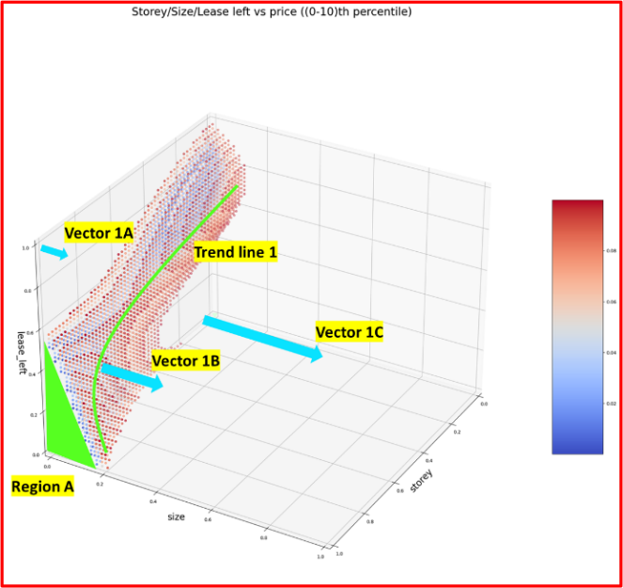

Figure 7: Numerical features v price (10-20 percentile)

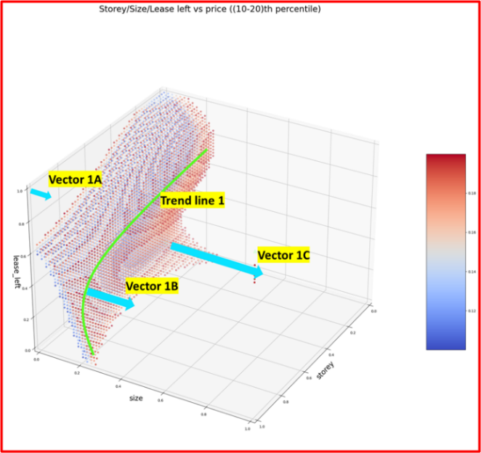

Figure 8: Numerical features v price (20-30 percentile)

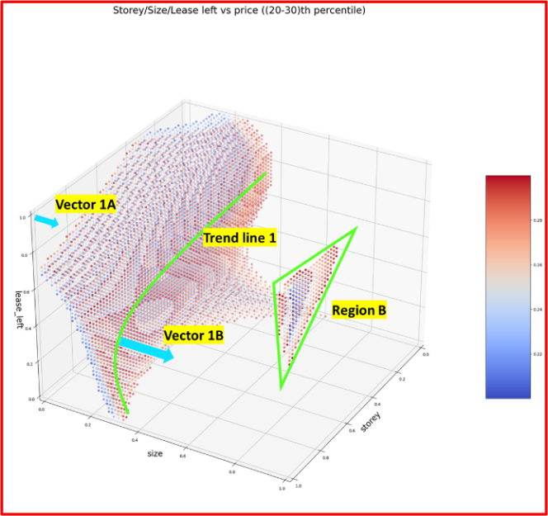

1. However, as price varied from the 30th to 50th percentile, some changes in the relationships between the numerical features and price were observed in hyperplane 1 and 2, as shown in Figures 9, 10, 11 and 12 below. These observations are as follows:
   1. In general, most of the trends due to hyperplane 1 relating to the relationship between price and the numerical features remained relevant. However, it was observed that as price approached the 50th percentile, the rate at which price increased as size increased decreased, as storey decreased, and lease left approached the 80th percentile. This is seen in the increase in curvature of the portion of trend line 1 marked by region C, in Figure 10, and the consequential "stretch" of hyperplane 1 in the direction of increasing size in the same figure.
   2. Interestingly, price was observed to increase, with a decreasing size, given that lease left is close to the 80th percentile, shown in the movement of hyperplane 2 in Figures 11 and 12 indicated by vector 2A.
   3. Furthermore, price was also observed to increase as lease left moved away from the 80th percentile, given that lease left remained close to the 80th percentile as shown in the "outward growth" of hyperplane 2 in Figures 11 and 12, as indicated by vectors 2Bi and 2Bii.
   4. Lastly, as seen in Figure 10 and 12, hyperplanes 1 and 2 appear to combine as price approaches and exceeds the 50th percentile. The implications of this are further discussed below.

|  |  |
| --- | --- |
| Figure 9: Numerical features v price (30-40 percentile) | Figure 10: Numerical features v price (40-50 percentile) |

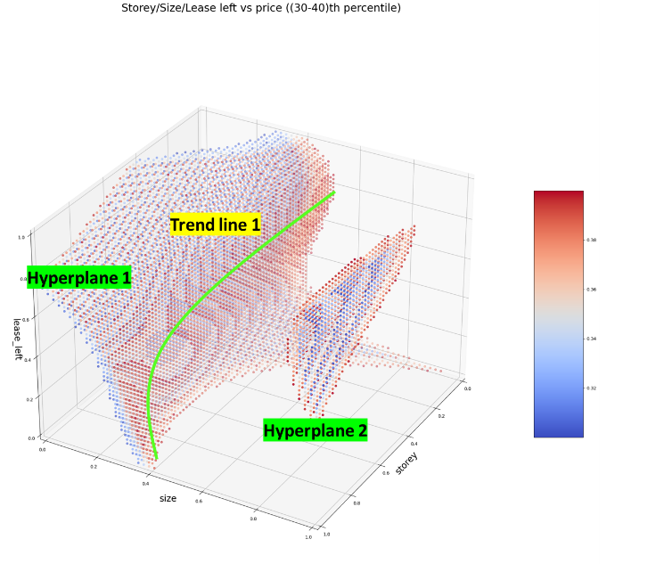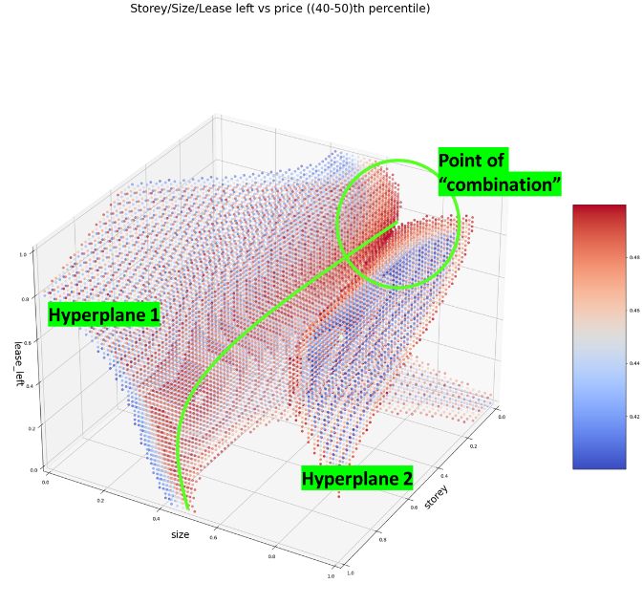

|  |  |
| --- | --- |
| Figure 11: Numerical features v price (30-40 percentile), rotated 90[°](https://graphemica.com/%C2%B0)in direction of decreasing size | Figure 12: Numerical features v price (40-50 percentile), rotated 90[°](https://graphemica.com/%C2%B0)in direction of decreasing size |

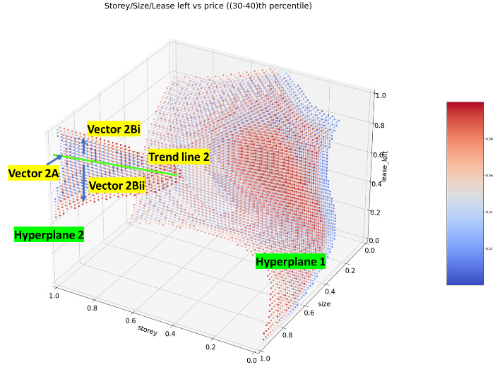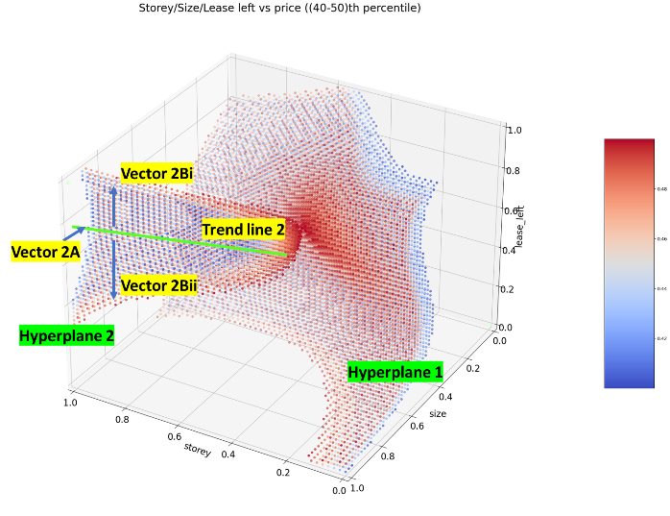

1. As price varied from the 50th to 60th percentile, hyperplanes 1 and 2, which encoded the relationships between the numerical features and price, appeared to "merge" into hyperplane 3, then appear to "split" into hyperplanes 3A and 3B, as price increased beyond the 60th percentile and above the 70th percentile, as shown in Figures 13, 14, 15 and 16. This led to the generation of below insights:
   1. As seen in the relative colours of the different "faces" of the hyperplanes mentioned in Figures 12, 13, 14 and 15, it can be said that there exist "hotspots" where the numerical features synergise best to drive up prices, leading to the high prices observed where the numerical features are closest to these "critical values" and lower the further they are from them.
   2. In the case of hyperplane 3A, considering the somewhat hemispherical shape of its inner surface as shown in Figures 13 and 15, which consists of points with a higher price than its outer surface, it can be said that there should exist only one distinct "hotspot" within this "hemisphere". Judging by the position of the "hemisphere", one such "hotspot" is where lease left and storey are close to the 100th percentile, and size is close to the 30th percentile.
   3. However, the solid enclosed by hyperplane 3B's inner surface more closely resembles a "flattened eggplant", implying the existence of more "hotspots", the exact numbers, and positions of which will likely only be clearer as price increases.

|  |  |
| --- | --- |
| Figure 13: Numerical features v price (50-60 percentile) | Figure 14: Numerical features v price (60-70 percentile) |

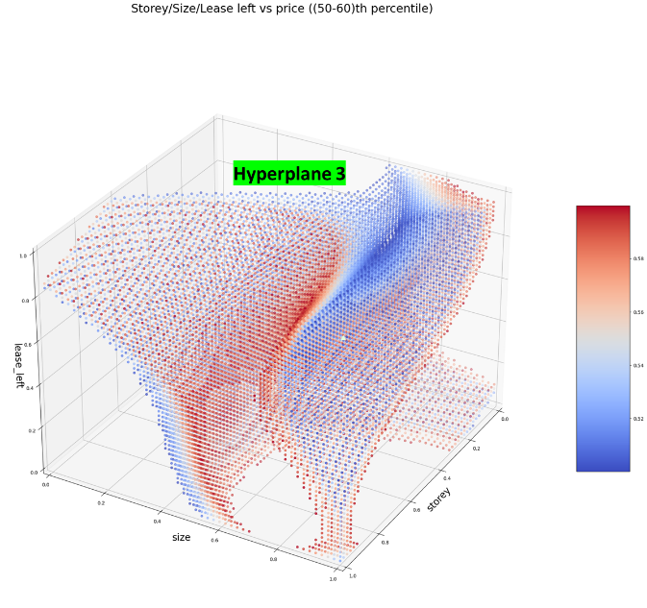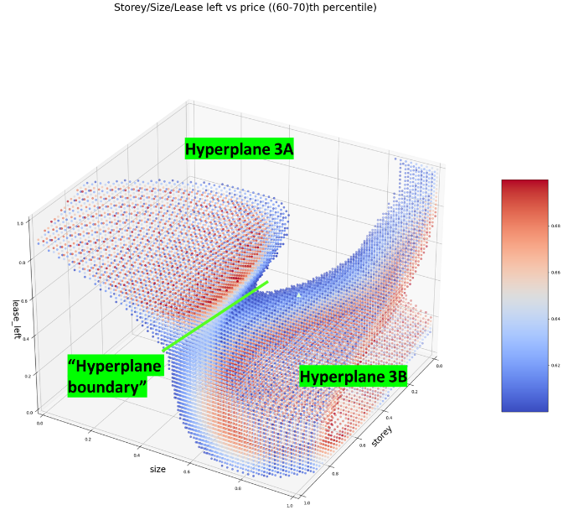

|  |  |
| --- | --- |
| Figure 15: Numerical features v price (50-60 percentile), rotated 90[°](https://graphemica.com/%C2%B0)in direction of decreasing size | Figure 16: Numerical features v price (60-70 percentile), rotated 90[°](https://graphemica.com/%C2%B0)in direction of decreasing size |

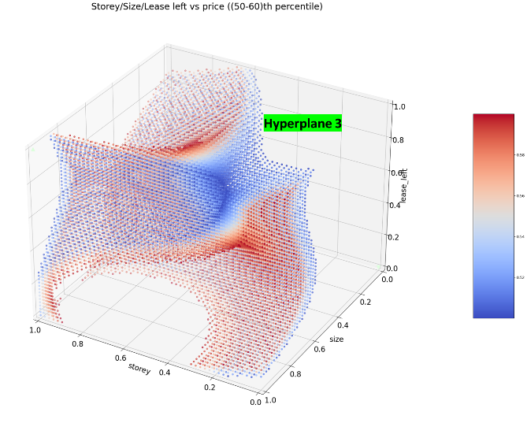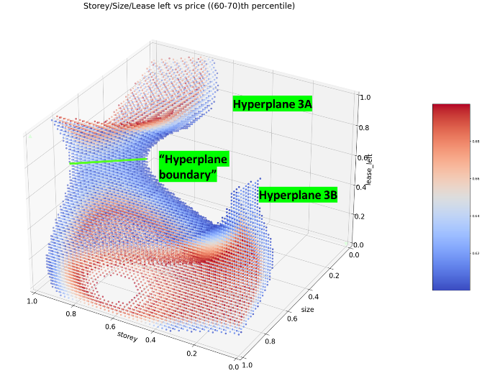

1. As price varied from the 70th to 100th percentile, the separation of the two hyperplanes (hyperplanes 3A and 3B, as shown in Figures 17 to 22), and thereby the existence of the two sets of "hotspots", remained clearly observable. In fact, the locations of these "hotspots" became much clearer as price increased. The analysis of these Figures are as follows:
   1. As seen in Figures 17 to 19, the existence of a "hotspot" enclosed by hyperplane 3A, at the point where lease left and storey are close to the 100th percentile, and size is close to the 30th percentile can be clearly seen, as discussed previously.
   2. However, the existence and positions of "hotspots" enclosed by hyperplane 3B are less clear, considering especially the fact that hyperplane 3B appears to be "filled" in Figures 16 and 19, and ceases to exist in Figures 17 and 20. This also implies a relative "weakness" of the "hotspots" enclosed by hyperplane 3B, which could imply that flats' prices are less likely to be influenced even if the numerical features of these flats are closer to these "hotspots" than the one enclosed by hyperplane 3A.
   3. Furthermore, given the relatively lower density of points within region D as shown in Figure 17, and existence of points corresponding to higher prices in regions E1 and E2 as shown in Figure 17, it can be said that the shape of hyperplane 3B implies the existence of two "hotspots”.
   4. These may, as seen in Figure 17, be said to be located at roughly where size is near the 80th percentile, storey is near the 60th percentile, and lease left is near the 20th percentile, and size is near the 100th percentile, storey is near the 0th percentile, and lease left is near the 40th percentile, for the first and second "hotspots”, respectively

|  |  |
| --- | --- |
| Figure 16: Numerical features v price (70-80 percentile) | Figure 19: Numerical features v price (70-80 percentile), rotated 90[°](https://graphemica.com/%C2%B0)in direction of decreasing size |

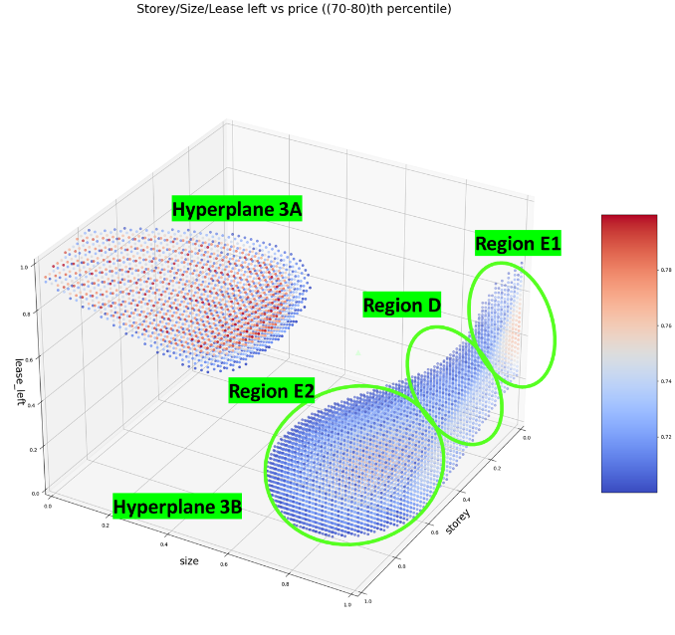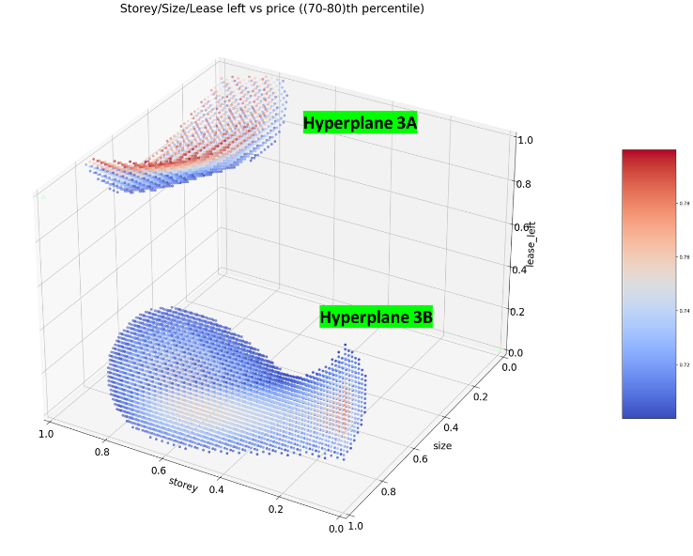

|  |  |
| --- | --- |
| Figure 17: Numerical features v price (80-90 percentile) | Figure 20: Numerical features v price (80-90 percentile), rotated 90[°](https://graphemica.com/%C2%B0)in direction of decreasing size |

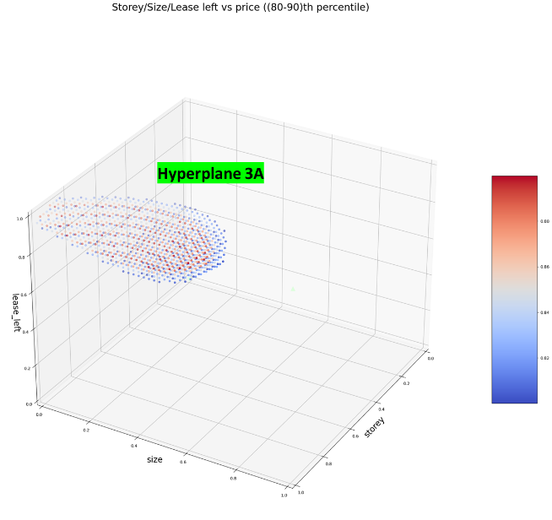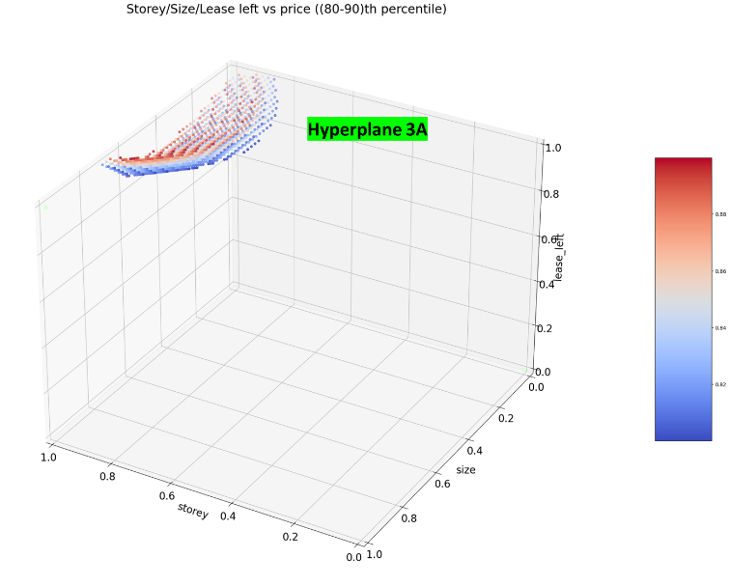

|  |  |
| --- | --- |
| Figure 18: Numerical features v price (90-100 percentile) | Figure 21: Numerical features v price (90-100 percentile) |

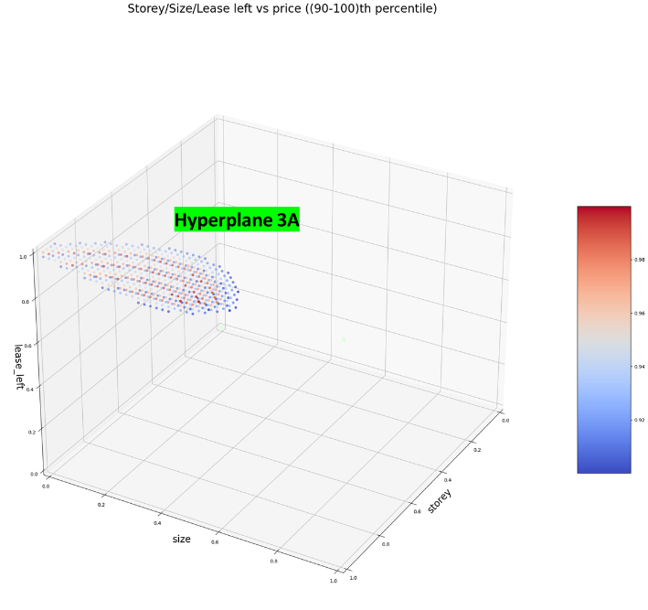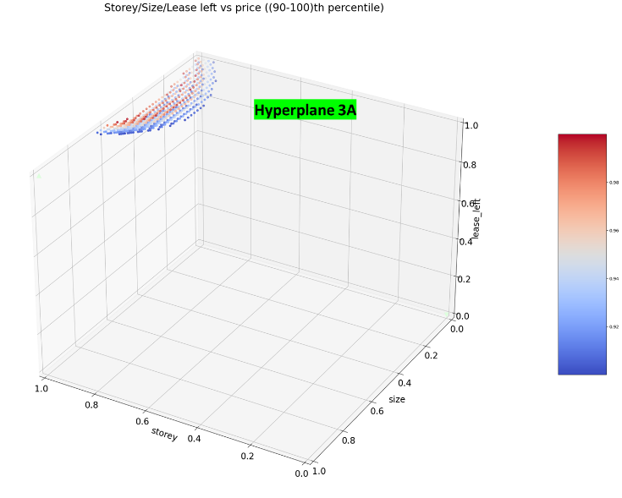

1. Additional analyses. In addition to the general observations mentioned above, further analysis of the relationships described may be done using the relevant visualisations attached in ***Annex C***.

RESULTS AND ANALYSIS (LEASE START PIPELINE)

27. In contrast to the numerical and categorical pipelines, the time series pipelines utilised ARIMA models rather than linear or ridge regression models.

30. In the case of the feature “lease start”, the optimal ARIMA Order was found to be (1, 1, 0). The optimal model weights for the first model autoregressive coefficient and constant for this feature were -0.4695 and 0.0013, respectively. This is shown in Figure 22 below.

Figure 22: Optimal model hyperparameters for lease start ARIMA

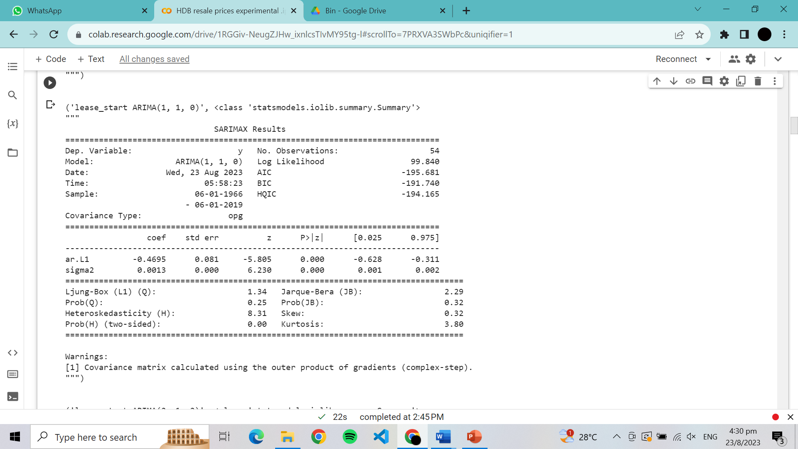

31. Considering also the generally positive trend between price and lease start, shown in the upward trend of Price with regards to lease start date as seen in Figure 23 below, it can be said that as lease start date increases, price increases at a moderately decreasing rate, in general, unless "shocks" occur.

Figure 23: Prices vs lease start, and model predictions

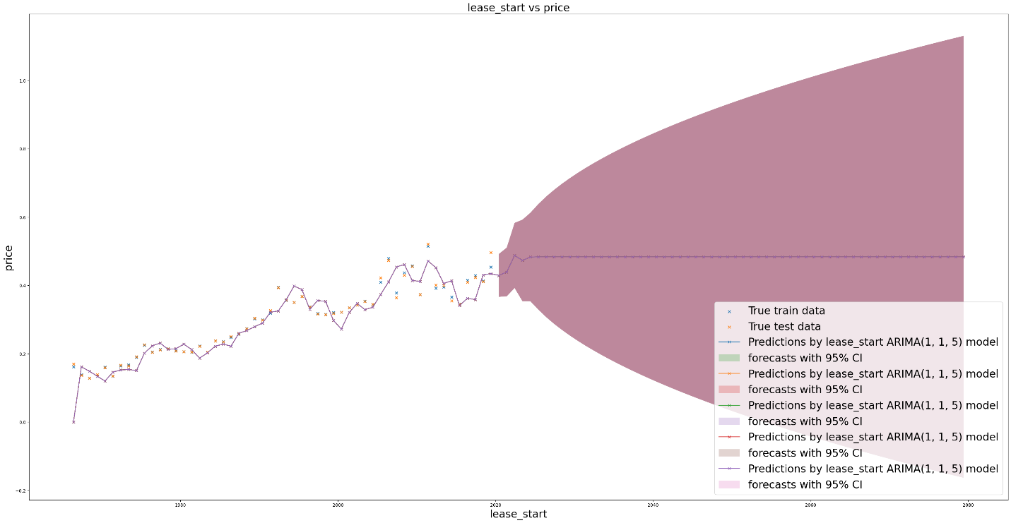

32. Furthermore, given also how the ARIMA model utilised had an order (1, 1, 0), it can be said that any rates of change of price with respect to lease start, at any time, is likely to propagate itself throughout time, impacting all future rates of change, albeit at an exponentially decreasing manner.

33. It is also interesting to note that the negative nature of the only autoregressive coefficient implies also that price changes as lease start date increases is more likely to fluctuate between positive and negative values than not, in the very short term. However, this is not likely to have any significant impact on Prices.

RESULTS AND ANALYSIS (SALE DATE PIPELINE)

32. However, in the case of sale date, using the same process for the case of lease start, the optimal ARIMA model order was found to be (4, 1, 0), while the optimal weights for the model's first, second, third and fourth autoregressive coefficients, and its constant, were -0.1035, 0.1818, 0.2434, 0.1312, and 2.475*10^-5 respectively, as shown in Figure 24.

Figure 24: Optimal model hyperparameters for sale date ARIMA

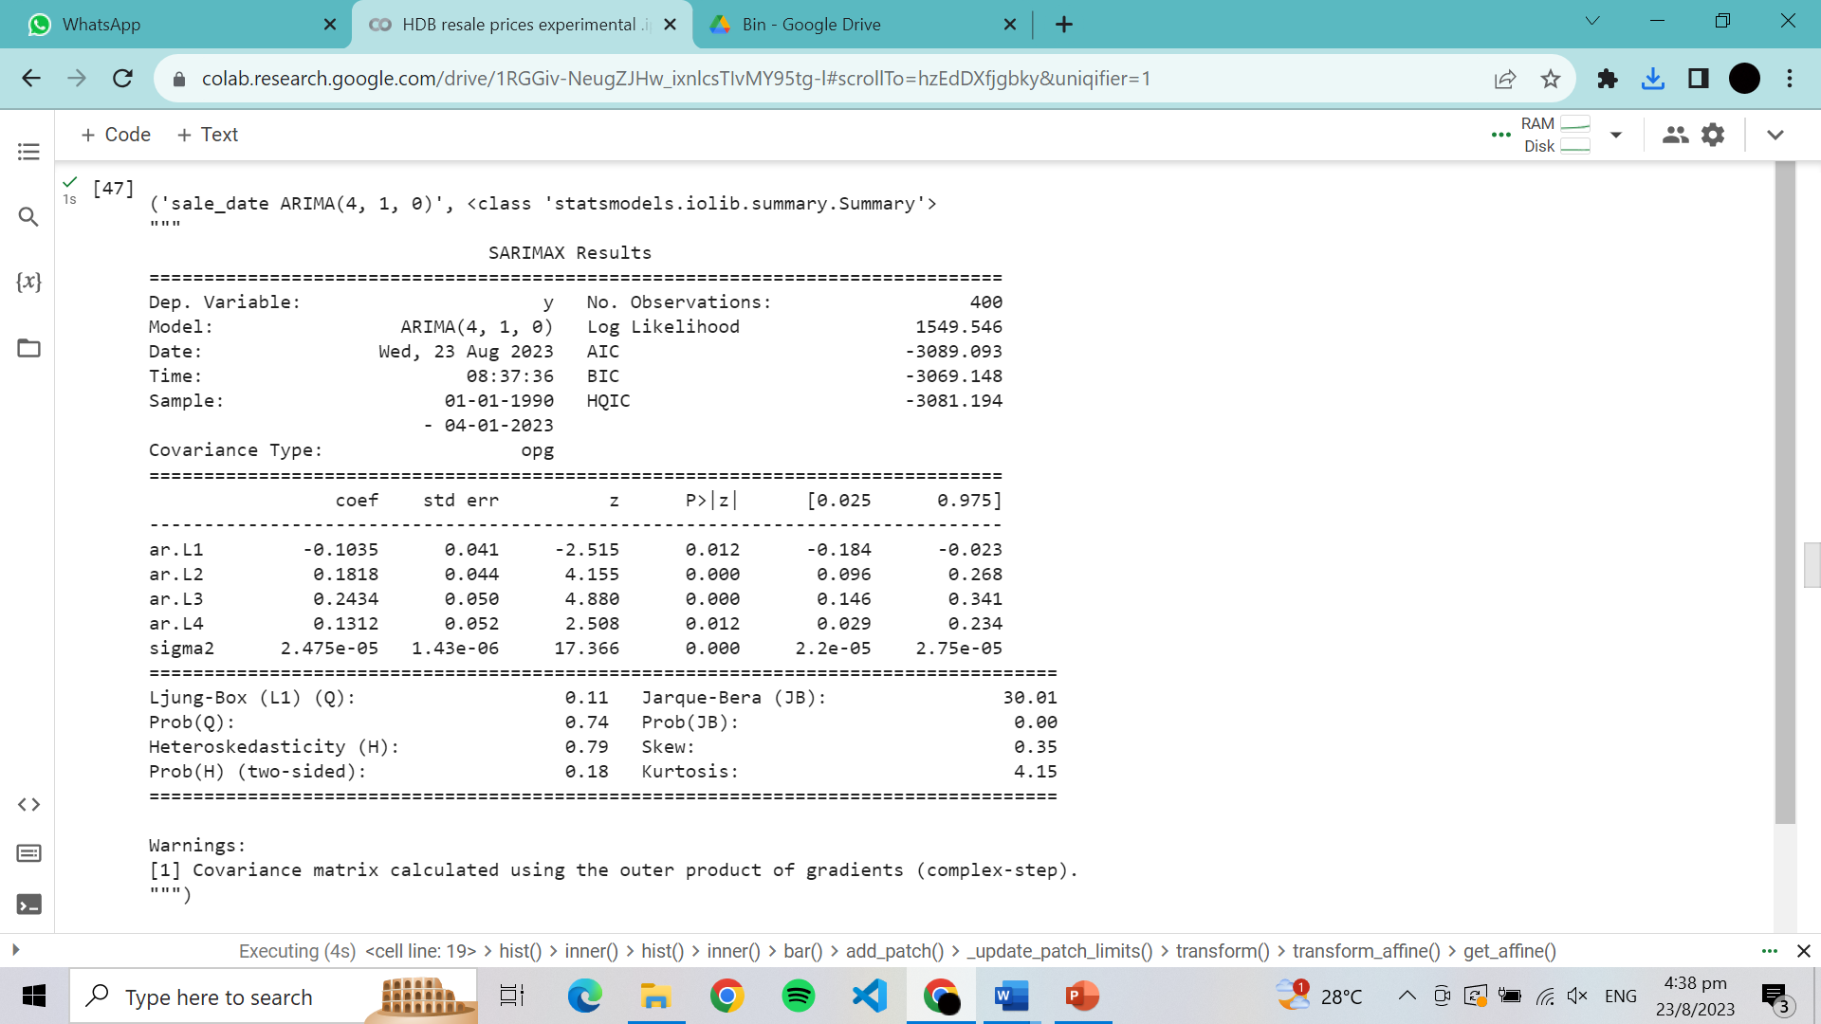

33. This implies that the rate of increase can be expected to decrease in magnitude over time, and price stability in prices can therefore be expected as time progresses.

34. However, this also implies that the signs of the rates of change of price are likely to increase in volatility as the rates of change of price decrease. However, this is likely to have a negligible impact on price, which should have settled close to a constant value by this point. This is illustrated in Figure 25 below.

Figure 25: Prices vs lease start, and model predictions

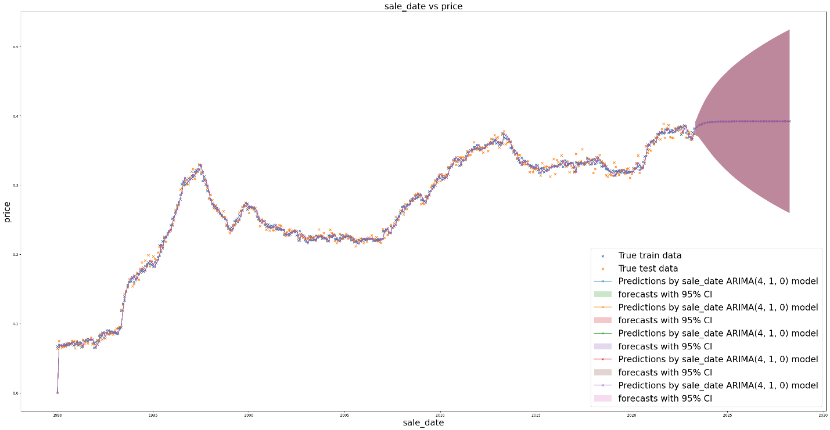

RESULTS AND ANALYSIS (META PIPELINE)

1. The Meta pipeline, much like the base pipelines it got its information regarding Prices from, performed extremely well, and much better than each of the base pipelines, with more 90% of its predictions having an error of under 0.05 (which is about $80 000 in real SGD after inverse normalisation), as seen in Figure 26. Diagrams illustrating its performance, relative to the other models, are shown below also in Figures 27 and 28, while diagrams illustrating its own performance are shown below in Figures 29 and 30.

Figure 26: Pipeline model absolute and percentage errors, for values of interest

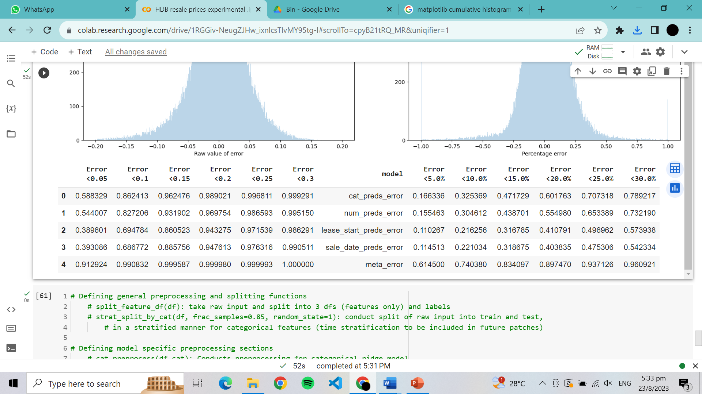

Figure 27: Prevalence of model percentage errors for all models

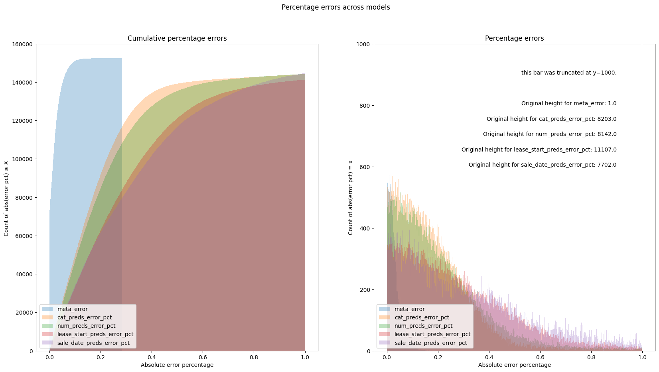

Figure 28: Prevalence of absolute model errors for meta model

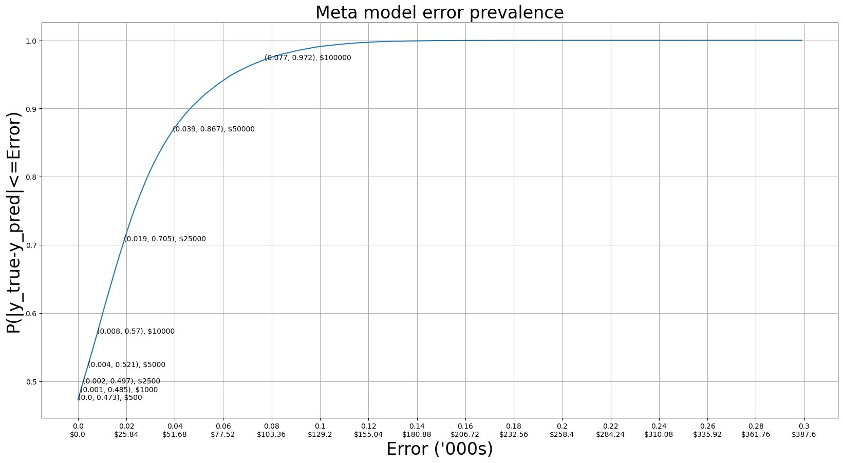

Figure 29: Prevalence of model errors for Meta model

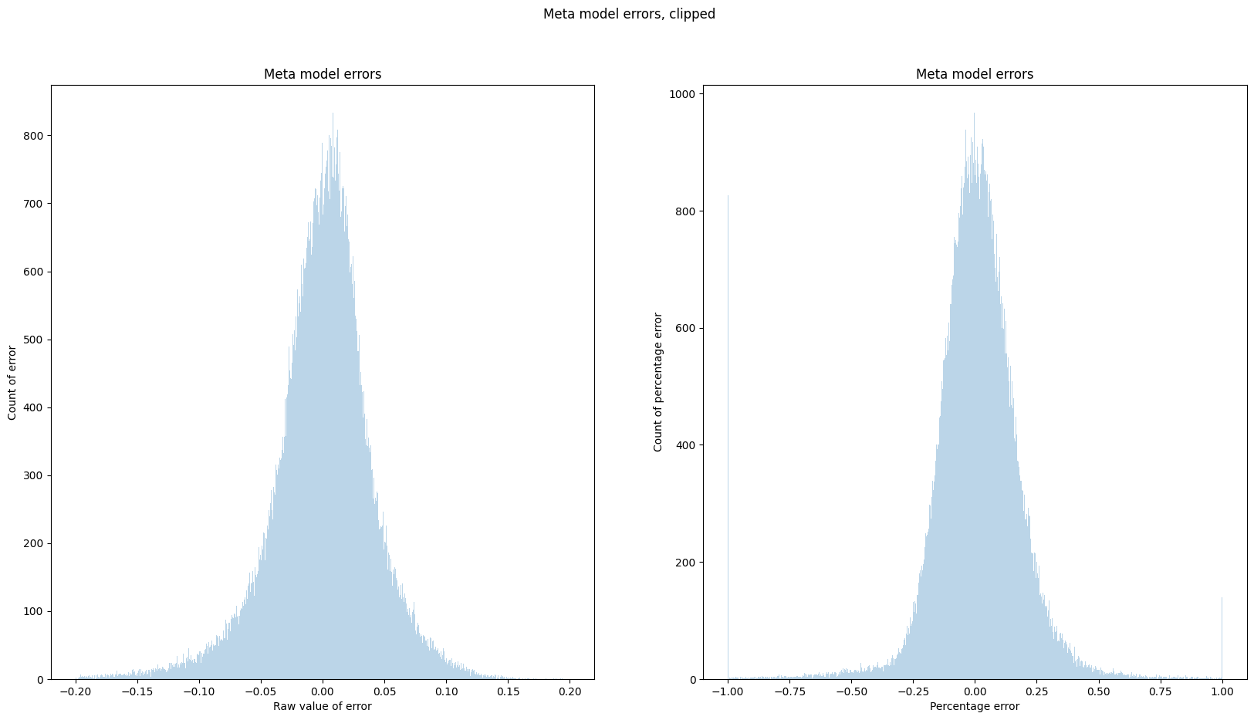

Figure 30: Prevalence of model percentage errors for Meta model



1. However, of greater importance for the purpose of this analysis is the Meta model’s weights for the different pipeline inputs, which are shown below in Figure 31.

Figure 31: Meta model weights

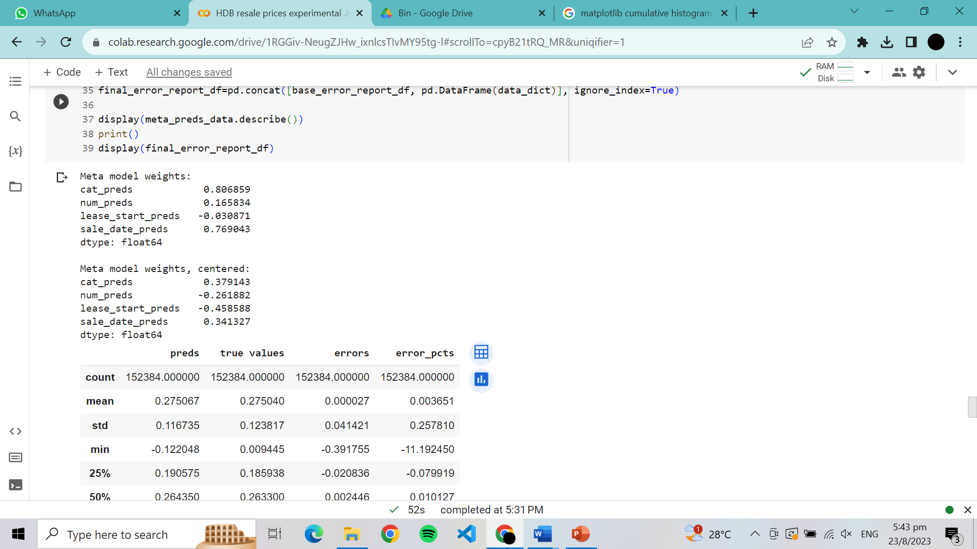

1. This implies that relatively speaking, the categorical features are the most important in determining Price, followed by sale date, numerical features, and finally lease start, in decreasing importance respectively.

LIMITATIONS

1. There were several limitations of this study, arising from the way the data was pre-processed, models were selected, and analysis was conducted.
2. The limitations of this study arising from the way the data was pre-processed, feature engineered, and selected are as follows:
   1. Non-inclusion of outlier classes for categorical variables due to their truncation. As mentioned in the section on “DATA COLLECTION, PREPROCESSING AND FEATURE ENGINEERING” above, data consisting of outlier classes for the categorical features were truncated. This makes the model, and consequently this analysis, blind to the relationships between these classes and Prices.
   2. Non-inclusion of street name as a feature. The street the HDB flat was on was not included in the analysis due to its high cardinality and the lack of computing resources at my disposal. This therefore caused the model and hence this analysis to be blind to the relationships between streets HDB resale flats are on and their Price, and hence the relationship between the information encoded within street name and price, such as distance from major transit nodes.
   3. Formatting of time series data as feature value-average Price pairs. The formatting of the time series data as mentioned above in the section on “DATA COLLECTION, PREPROCESSING AND FEATURE ENGINEERING” could have led to inaccuracies in representing Prices over the time series feature values, due to the existence of outliers of Price for each feature value. However, this is likely to have little impact on the representativeness of the data analysed due to the large number of data points for each given time series feature value.
   4. Utilisation of all data points in time series analysis. The use of all data points for the time series pipelines could have led to the inability of the model and hence this analysis to consider the impact that variances in other features’ prevalence over the feature values could have on the detected relationships between the feature values and price. However, this was a risk that had to be taken due to the lack of segment prevalence over the feature ranges considered, for all segments.
3. The limitations of this study arising from the way the models for the base and Meta pipelines were selected are as follows:
   1. Utilisation of R2 score as a means of model selection and hyperparameter tuning. R2 score was used as it provided better explanatory power (given its scale invariability), and was generally insensitive to outliers, which I felt would help in the model’s ability to aid in this analysis by better modelling relationships rather than outliers. However, more robust models might have been selected if other metrics like Mean Absolute Error were utilised for hyperparameter tuning and model selection, though this appears unlikely.
4. The potential limitations of this study arising from the way the analyses for it were conducted are as follows:
   1. This study was conducted independently, which may have impacted its robustness due to the lack of diversity of perspectives in its generation.
   2. This study was also conducted by a person without any real formal training in ensemble learning techniques and regression analysis, or even a relevant university degree, which may have impacted the technical robustness of the methodologies used and hence the analysis derived from it due to a lack of knowledge.

CONCLUSION

1. In summary, this analysis found numerous links between HDB resale flats’ features and their resale prices, as outlined above.
2. This analysis also found that the relationships between HDB resale flats’ features and their resale prices are numerous and varied, with the relevance of the relationships discovered being dependent on the needs of the users of this study.
3. However, any analyses done with the aid of this study ought to be done with other means of validation of the findings of these analyses, due to the potential lack of robustness of this study owing to its creator’s lack of formal education and experience in this field.
4. Therefore, there exists incredible potential for further research into the relationships analysed in this study, and refinement of the ensemble model utilised.
5. This study also highlights the incredible potential of ensemble machine learning techniques, and AI in general, in the analysis of data for the purpose of making better informed decisions, for all reasons.

RECOMMENDATIONS

Suggest possible courses of action based on the insights gained from the analysis, such as policy changes or areas for further investigation.

1. Given the nature of this project, no hard recommendations can be made regarding follow up actions that ought to be taken. However, one need only consider the outcomes of this analysis (i.e., The relationships between the features analysed and Price determined), and one’s own objectives, to determine the appropriate follow up actions that ought to be taken.
2. However, it is also recommended that greater resources be invested into the use of machine learning and AI for the purpose of data analysis for better decision making, due to its incredible potential for high returns, which I believe has been demonstrated through this project.

REFERENCES

1. Data utilised for this analysis:
   1. Data regarding rates of inflation in Singapore were sourced from Singstat, at https://tablebuilder.singstat.gov.sg/table/TS/M212881.
   2. Data regarding HDB resale flat features and prices were sourced from data.gov.sg, at https://beta.data.gov.sg/datasets/189/view.
2. Additional information regarding the references used may be found in ***Annex D***.

ACKNOWLEDGEMENTS

1. I would like to thank the internet for the provision of the university lecture notes and articles on machine learning I utilised to aid in this analysis and the creation of the model utilised.
2. I would also like to thank the many cats I befriended which provided me with emotional support as I completed this project.

CONTACT INFORMATION

1. I may be reached at www.linkedin.com/in/teo-joshua regarding this project.

ANNEXES

Annexes:

|  |  |
| --- | --- |
| A. | Lower-level model architecture |
| B. | Additional visualisations generated from the Categorical pipeline |
| C. | Additional visualisations generated from the Numerical pipeline |
| D. | References |

# ANNEX A: LOWER-LEVEL MODEL ARCHITECTURE

HIGH-LEVEL OVERVIEW OF MODEL ARCHITECTURE

1. As discussed in the report, the high-level overview of the model architecture is as follows:
   1. Data regarding HDB Resale flat sales are pre-processed and selected in general. This data is then split for feeding into their respective base pipelines.
   2. Each base pipeline further pre-processes the data as needed, before feeding it into their respective regression models.
   3. These models’ outputs are then recombined and fed into the Meta pipeline, which feeds them into the Meta model, which then produces predictions of Prices given HDB flat features.
2. This is illustrated in Figure A1 below.

Figure A1: High level overview of model architecture

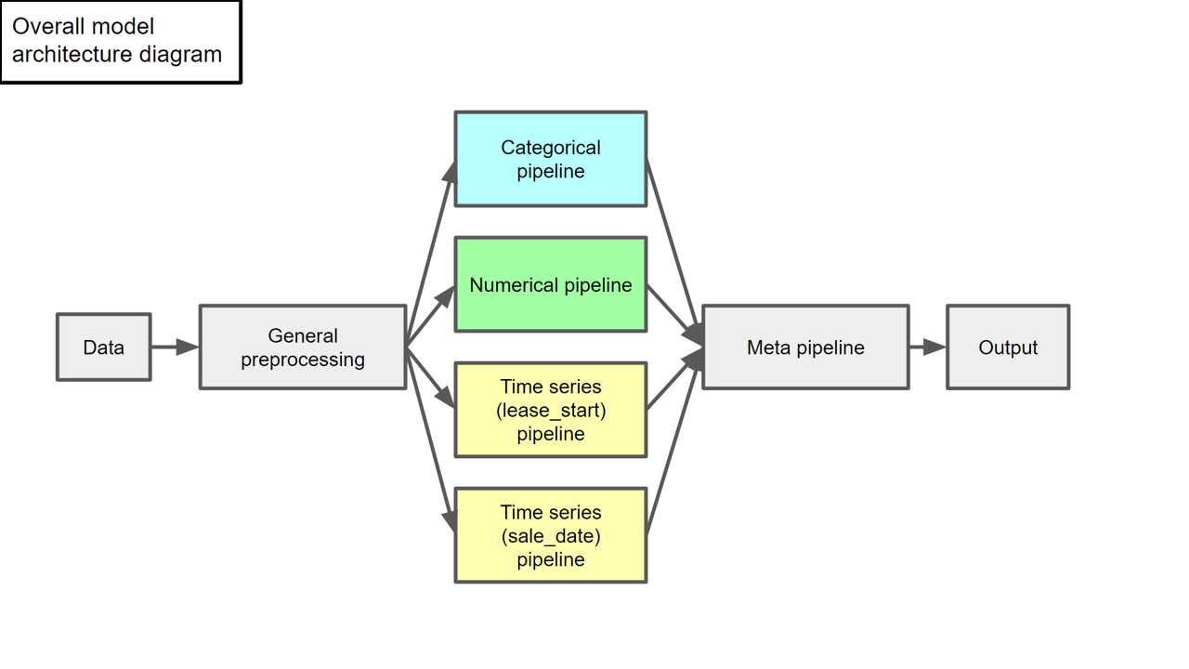

GENERAL PRE-PROCESSING

1. As shown in Figure A2 below, all the data first undergoes general preprocessing, before being split and fed into their respective pipelines. This entails the following steps:
   1. Cleaning of strings. This involves making all feature values stored as strings as meaningful as possible, by converting them all to pure uppercase and standardising naming conventions over time (such as by replacing hyphens with spaces), to allow for identical feature values to be represented as such.
   2. Truncating categorical feature values. This refers to the truncation of data points with feature values from categorical feature classes that constitute less than 5% of the average number of occurrences of each class for that feature. This is to minimise the occurrence of categorical outliers and reduce the cardinality and hence dimensionality (after categorical preprocessing) of the data. This also helps reduce computational requirements of the project.
   3. Adjustment of prices for inflation. This is done to allow for a fair comparison of HDB Resale prices across different time scales.
   4. Normalising numerical columns. This is to allow for model robustness and ease of interpretation of model weights.
   5. Renaming and reordering columns. This is to allow for ease of coding.
   6. Addition of lease left. Additionally, information regarding the amount of lease that is left on a flat is added, generated by calculating the difference between the amount of lease on a HDB flat (99 years) and the time between the flat’s creation (lease start date) and its sale (sale date), correct to the nearest year.

Figure A2: Low-level overview of general preprocessing

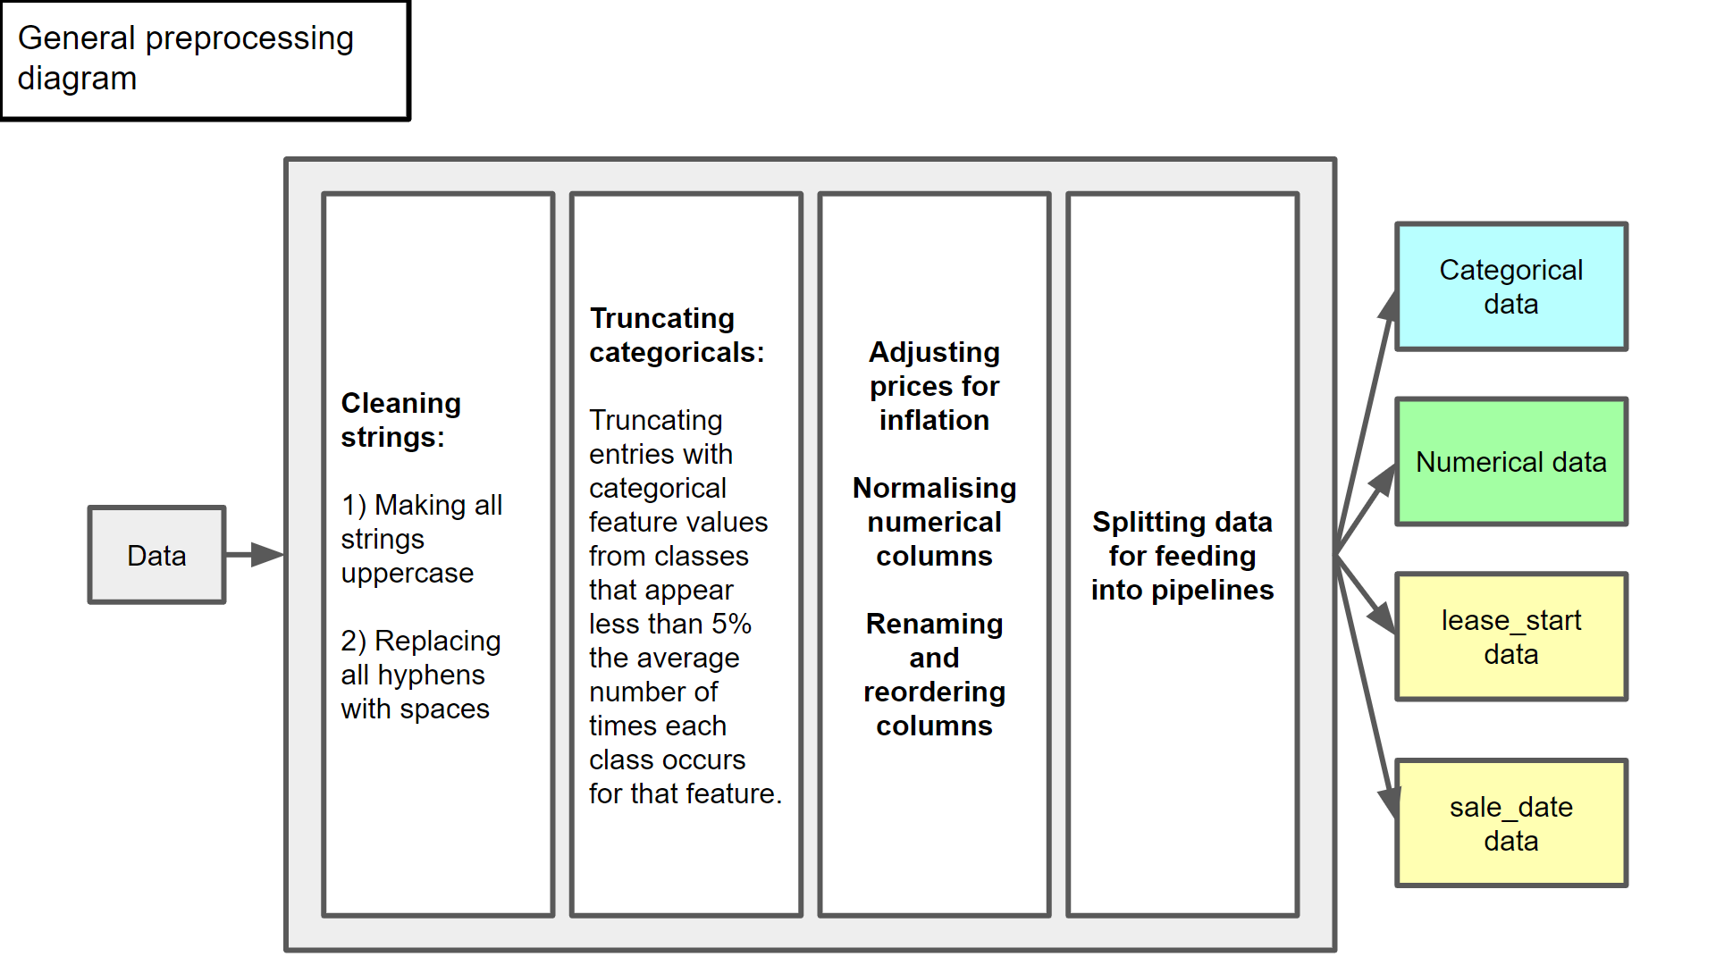

CATEGORICAL PIPELINE

1. In the case of the Categorical pipeline, the features inputted, for each data entry is information regarding:
   1. The flat’s model name.
   2. The flat’s type.
   3. The town the flat was in.
   4. The Price of the flat.
2. As shown below in figure A3, this data then undergoes:
   1. Further feature engineering, in the form of feature crossing.
   2. Feeding into the Categorical pipeline model, a Ridge regression model with a regularization coefficient of 6.

Figure A3: Low-level overview of Categorical pipeline

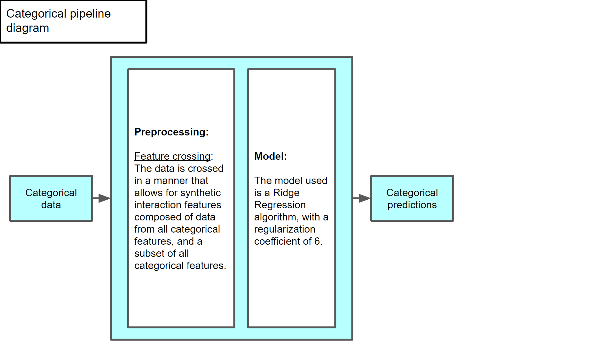

1. After which, predictions for Price based on the categorical features are generated, for feeding into the Meta model.

NUMERICAL PIPELINE

1. In the case of the Numerical pipeline, the following information is inputted for each data entry, into the pipeline:
   1. The size of the flat.
   2. The expected floor the flat is on, computed by taking the mean of the ranges the flats are listed on (for example, a flat listed to be on the “04 TO 06 STOREY) is taken to be on the 5th floor.
   3. The amount of lease left on the flat.
   4. The flat’s Price.
2. As shown below in figure A4, this data then undergoes:
   1. Feature crossing and “polynomialisation”. This allows for the analysis of non-linearity in the relationships between the numerical features and Price.
   2. Feeding into the Numerical pipeline model, a Linear Regression algorithm.

Figure A4: Low-level overview of Numerical pipeline

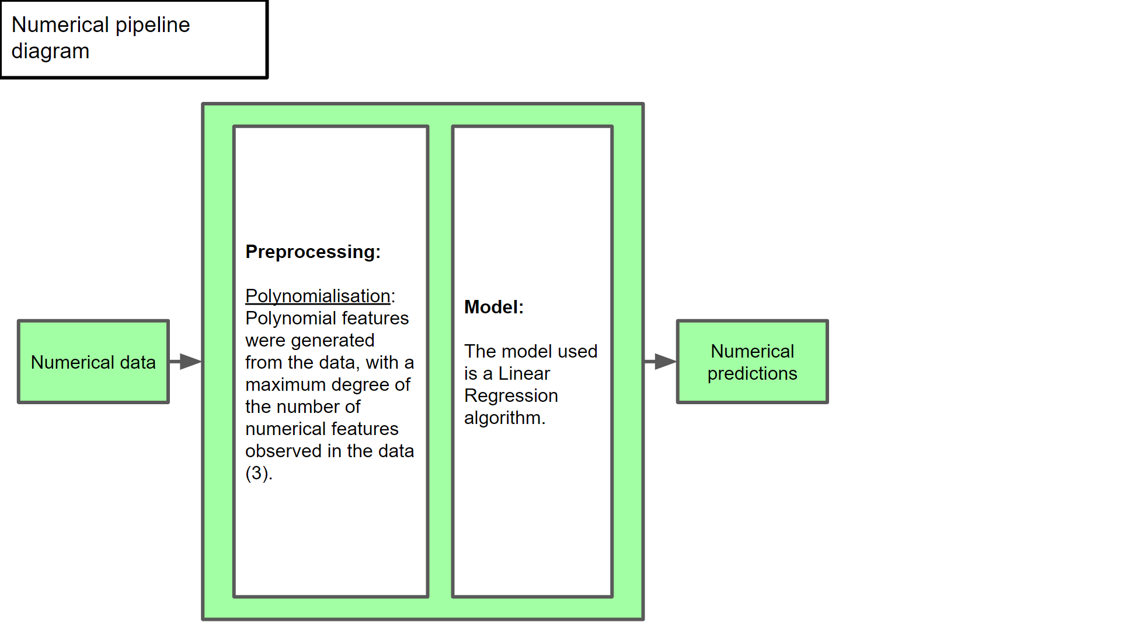

1. After which, predictions for Price based on the numerical features are generated, for feeding into the Meta model.

TIME SERIES PIPELINES

1. In the case of the Time series pipelines, the information to be inputted (namely the feature values and corresponding mean Prices) are organised into a Pandas Series, with the relevant feature value forming the index and the Prices forming the values.
2. After this, the data is fed into ARIMA models, with orders appropriate for their respective pipelines, namely (6, 1, 0) and (1, 1, 5), for the sale date and lease start pipelines respectively.
3. These are illustrated in Figures A5 and A6 below.

Figure A5: Low-level overview of lease start pipeline

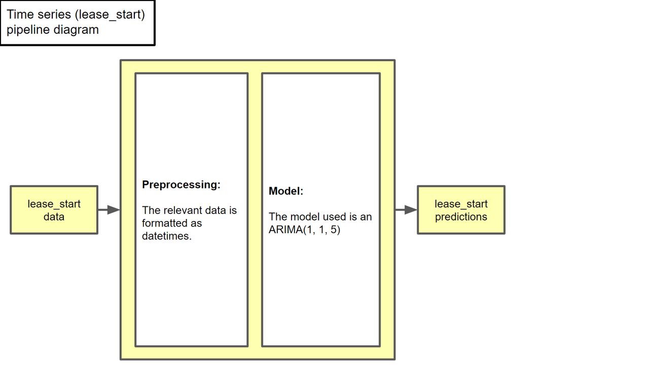

Figure A6: Low-level overview of sale date pipeline

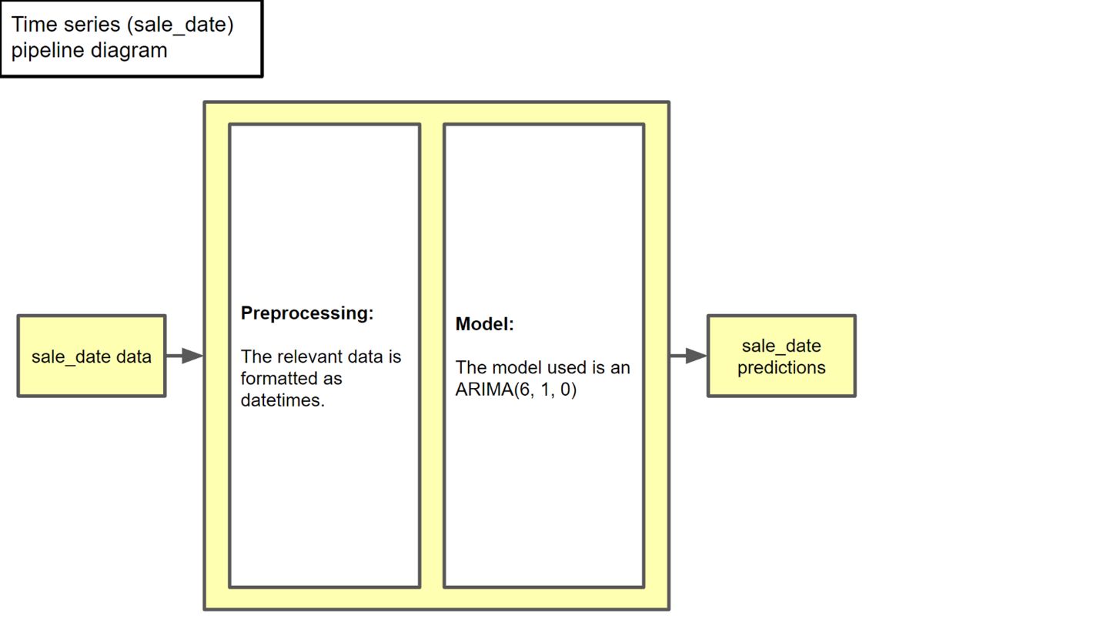

1. After which, predictions for Price based on these features are generated, for feeding into the Meta model.

META PIPELINE

1. In the case of the Meta pipeline, predictions from the base pipelines were combined, fed into it, then fed into a stacking regressor (a linear regression model), before predictions for Price were generated from there. This is illustrated in Figure A7 below.

Figure A7: Low-level overview of Meta pipeline

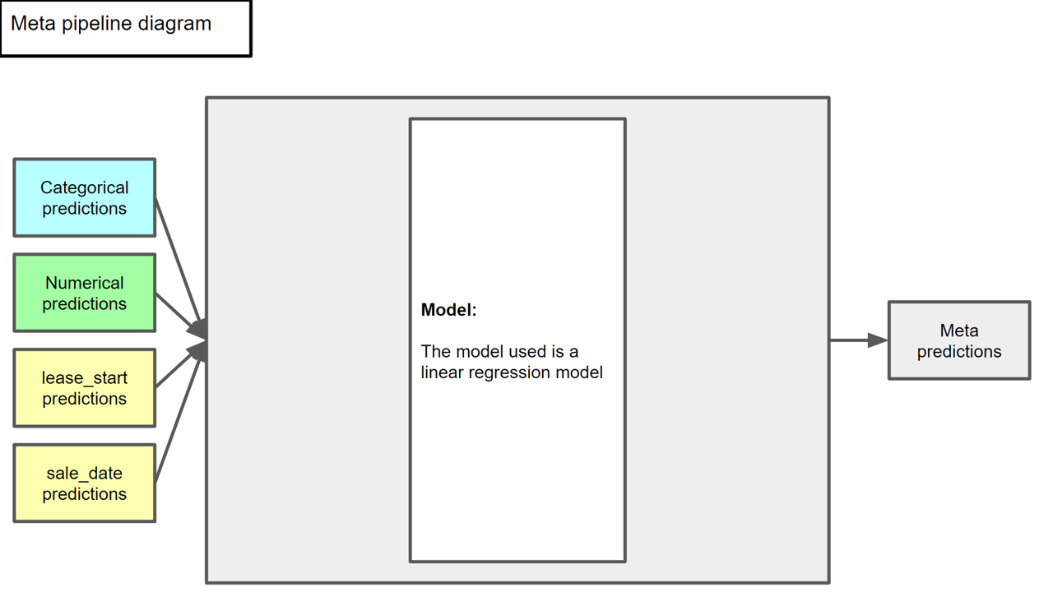

# ANNEX B: ADDITIONAL VISUALISATIONS GENERATED FROM THE CATEGORICAL PIPEINE

1. As discussed in the report, the visualisations generated from the Categorical pipeline, which illustrate the relationship between the categorical features and Price are shown below in figures B1 to B5. The visualisations shown in the report itself are also included, for easy reference.

Figure B1: Absolute model weights by segments (top 20)

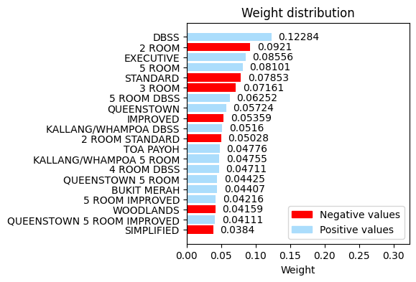

|  |  |
| --- | --- |
| Figure B2: Absolute model weights by raw feature, coloured by feature | Figure B3: Absolute model weights by raw feature, coloured by sign |

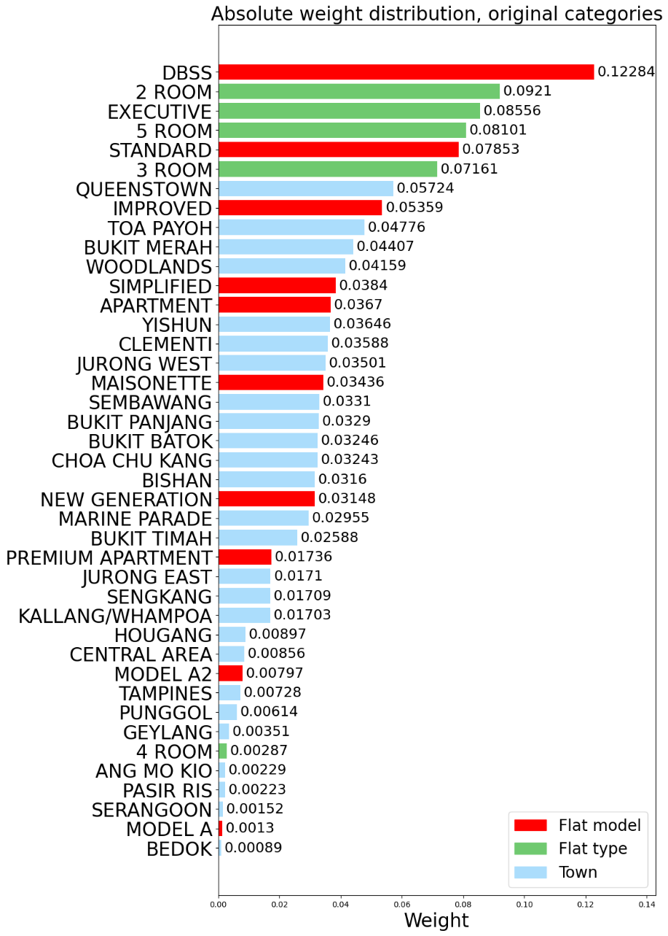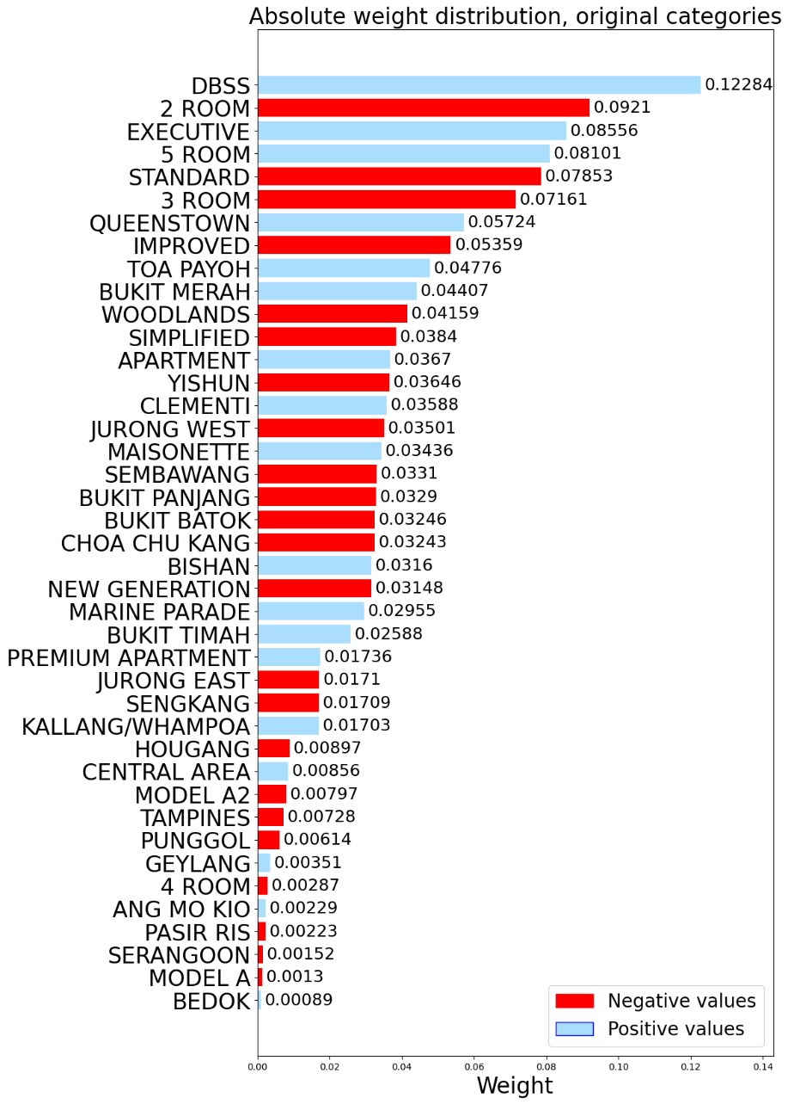

Figure B4: Absolute model weights of segments by raw feature components

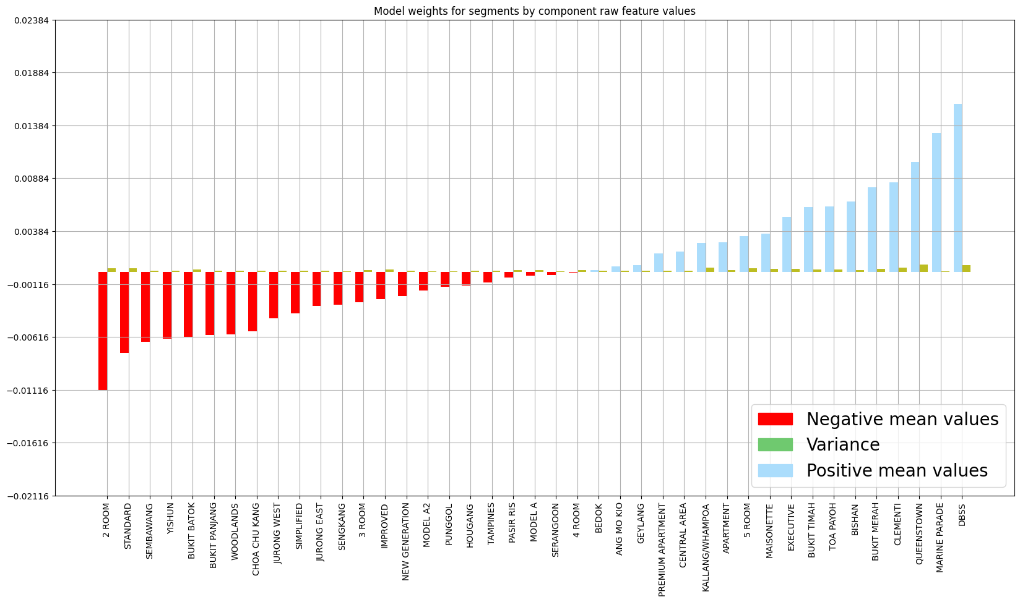

Figure B5: Absolute model weights by interaction feature, coloured by sign

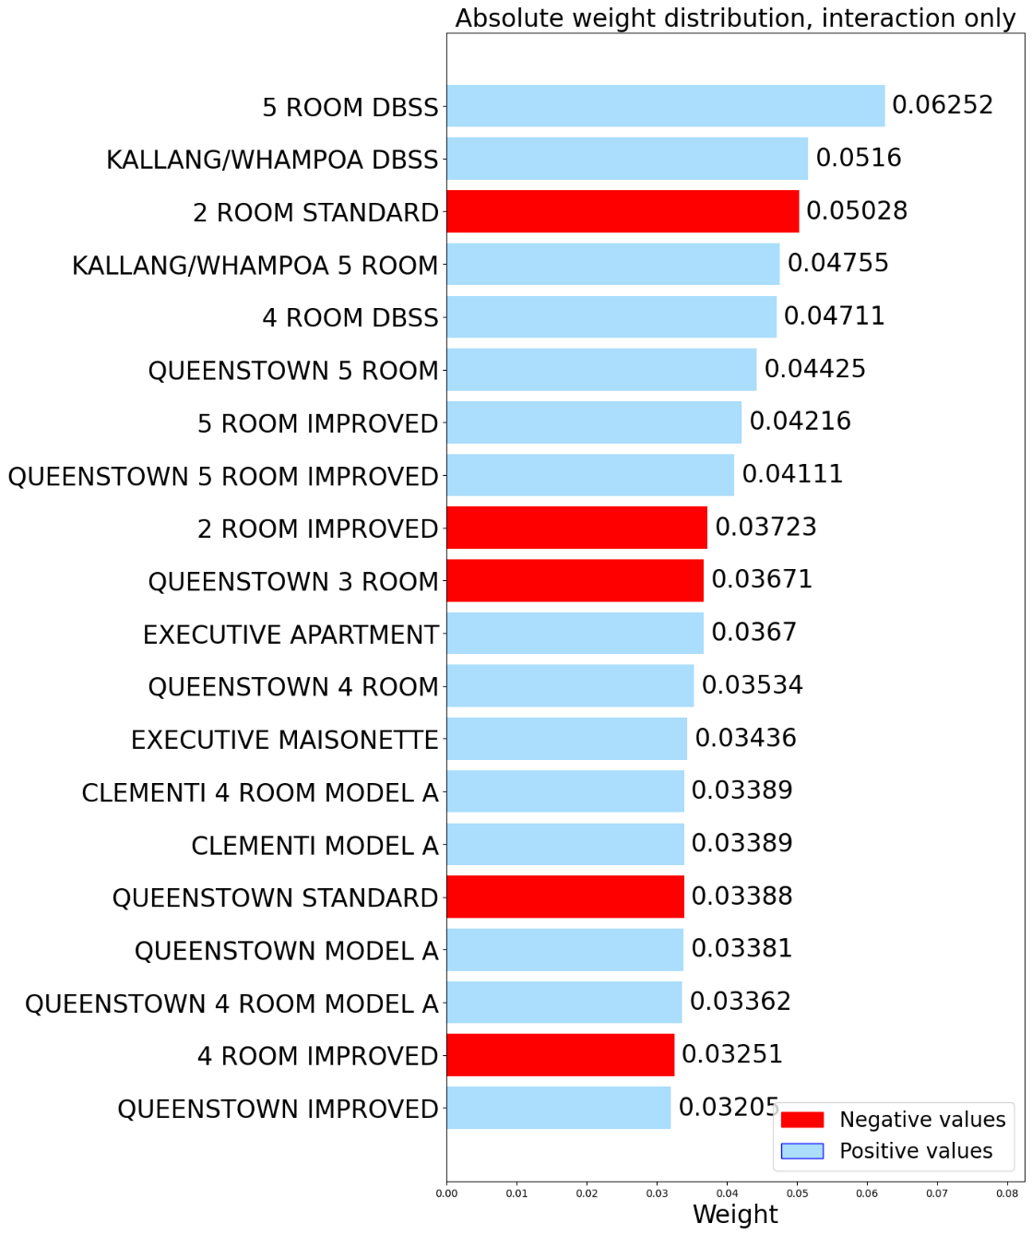

# ANNEX C: ADDITIONAL VISUALISATIONS GENERATED FROM THE NUMERICAL PIPEINE

1. As discussed in the report, the visualisations generated from the Numerical pipeline, which illustrate the relationship between the categorical features and Price are shown below in figures C1 to C10. The visualisations shown in the report itself are also included, for easy reference.
2. Note that in each visualisation, there exist two “anchor points”, which are markers for critical values within the visualisation that serves as a visual guide to aid in visualisation of the data displayed, in 3 dimensions. These are displayed as an upward pointing green triangle marking the point where size, storey, and lease left are maximum, and a downward pointing green triangle marking the origin.
3. Each visualisation displays all the points that will fall within the given percentile range, for the set of feature values corresponding to these points, based on model predictions. This therefore makes these visualisations, in essence, snapshots of a 4-dimensional graph, of size, storey, lease left (which are the numerical features analysed), and the prices corresponding to these values as predicted by the Numerical pipeline model, as price varies.

Figure C1: Numerical features v Price, 0-10th percentile, 3 views.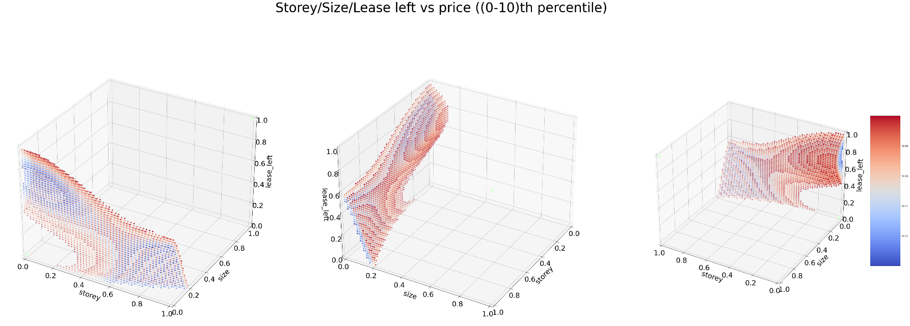

Figure C2: Numerical features v Price, 10th-20th percentile, 3 views.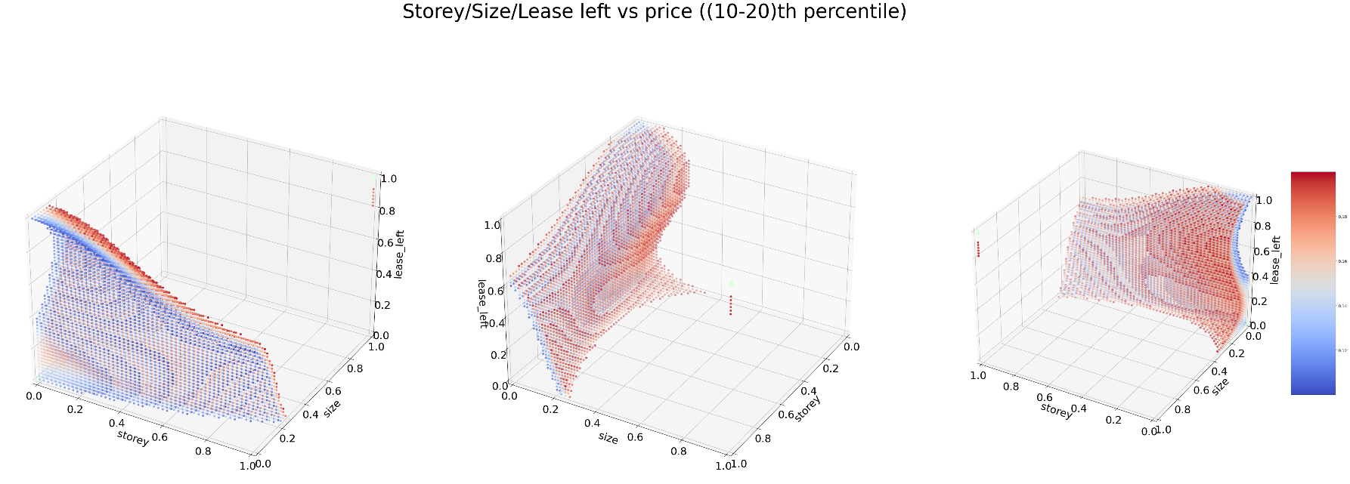

Figure C3: Numerical features v Price, 20th-30th percentile, 3 views.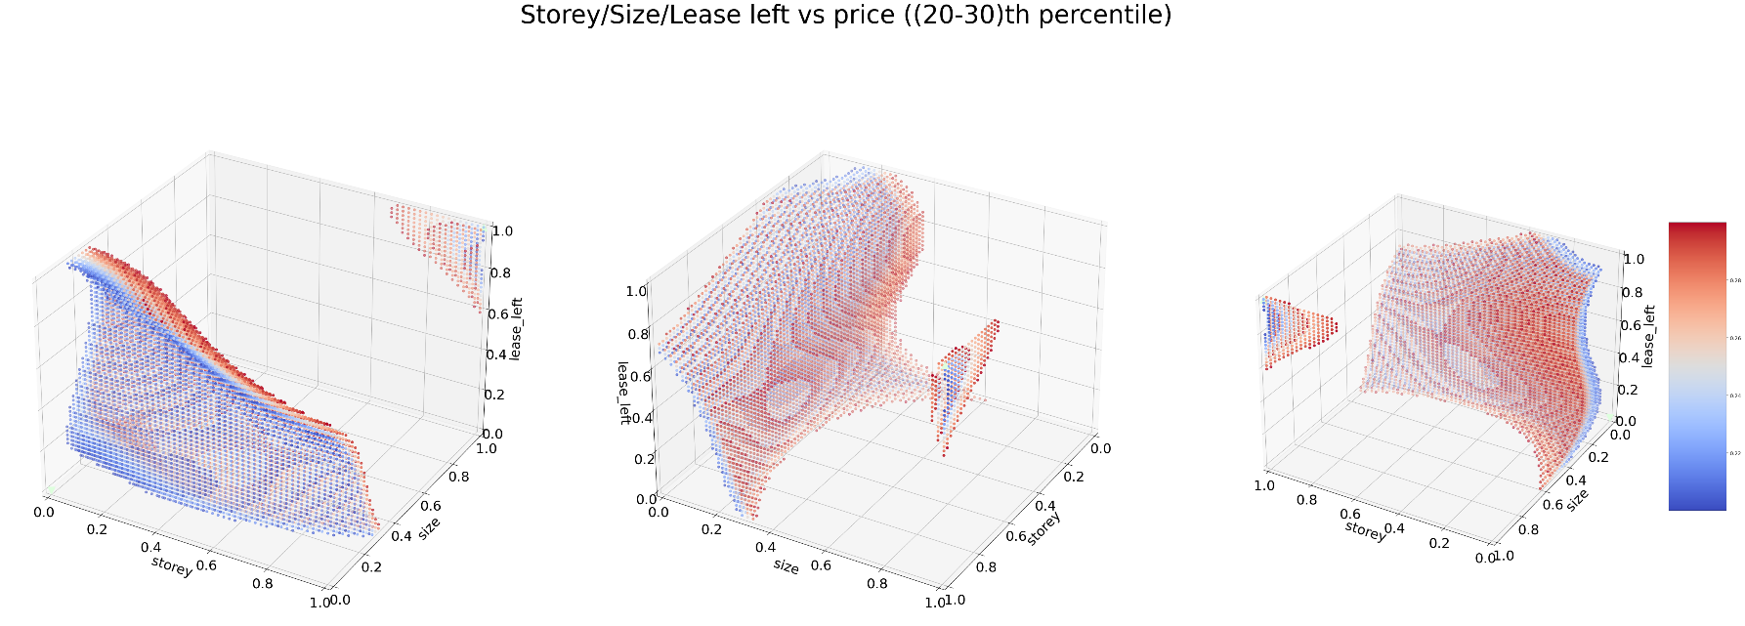

Figure C4: Numerical features v Price, 30th-40th percentile, 3 views 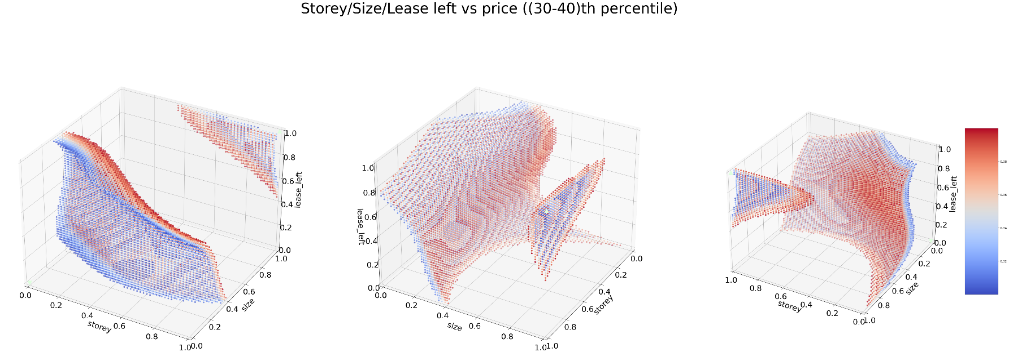

Figure C5: Numerical features v Price, 40th-50th percentile, 3 views 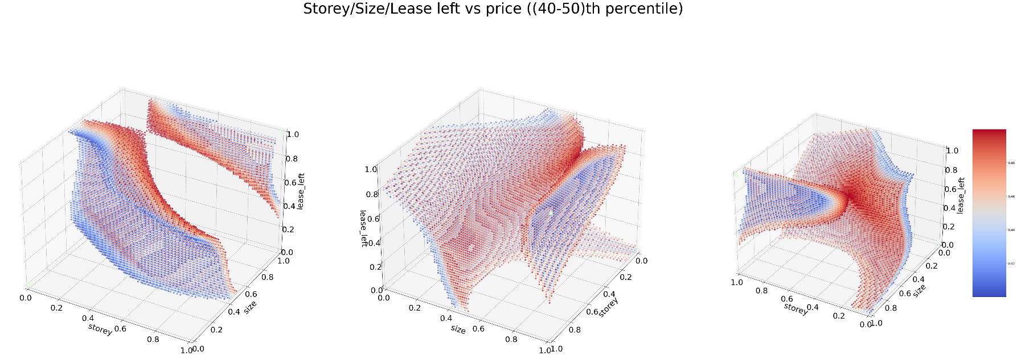

Figure C6: Numerical features v Price, 50th-60th percentile, 3 views 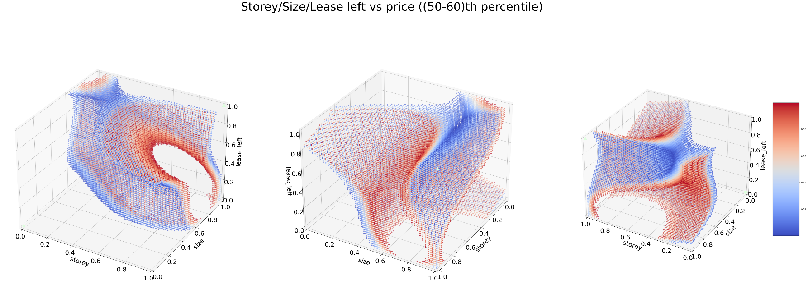

Figure C7: Numerical features v Price, 60th-70th percentile, 3 views

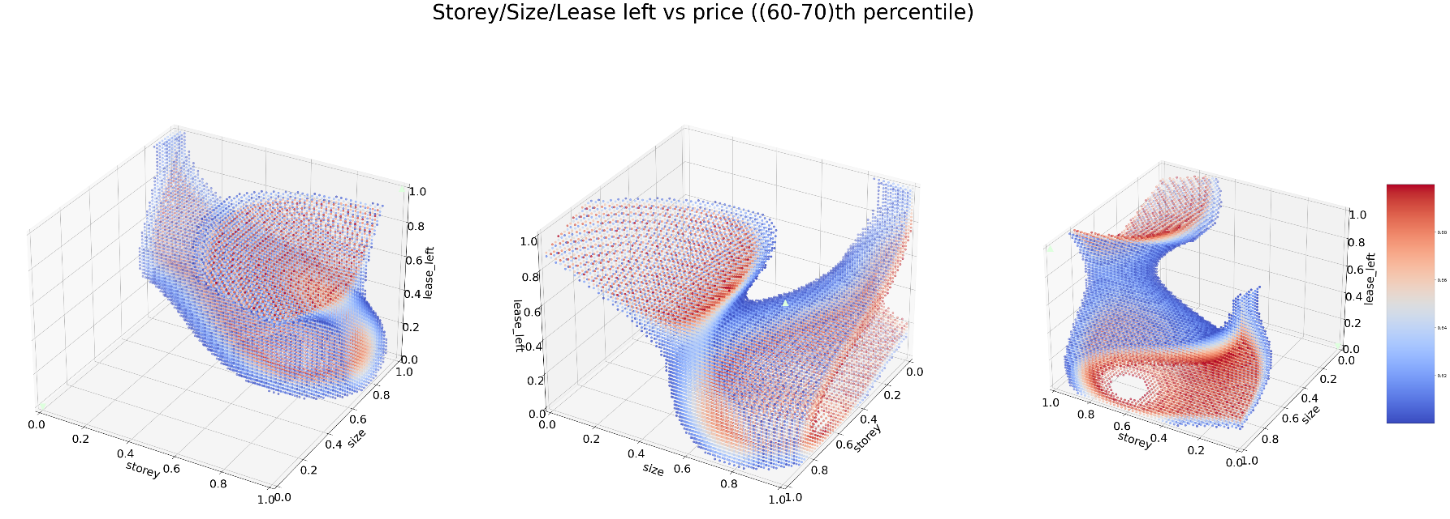

Figure C8: Numerical features v Price, 70th-80th percentile, 3 views 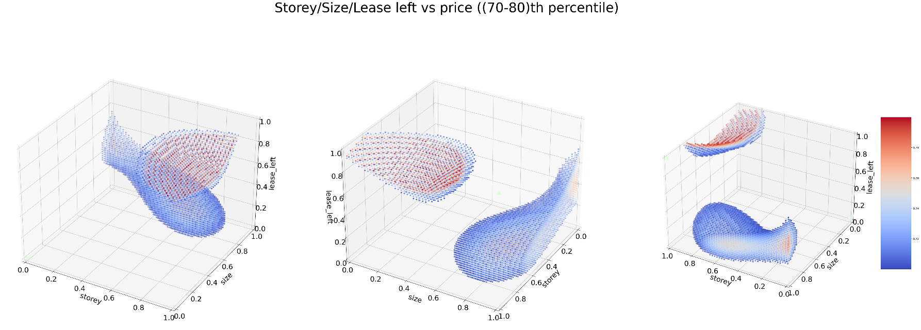

Figure C9: Numerical features v Price, 90th-90th percentile, 3 views 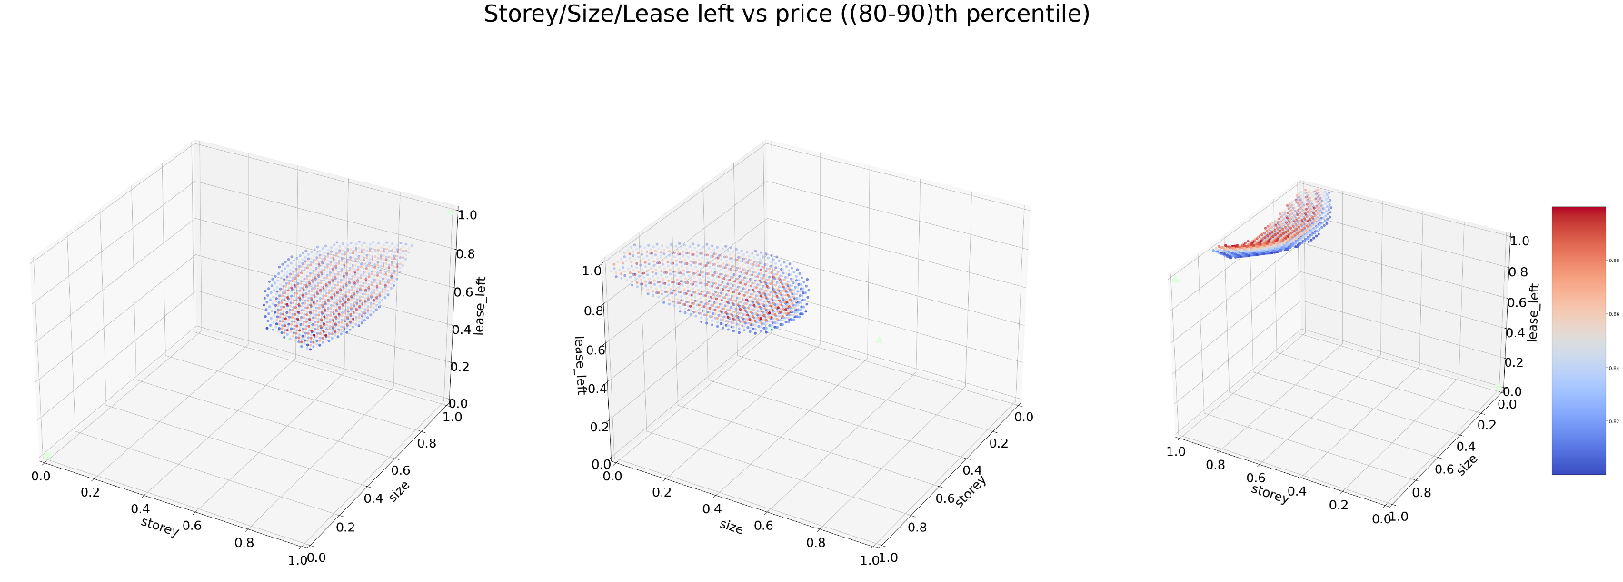

Figure C10: Numerical features v Price, 90th-100th percentile, 3 views

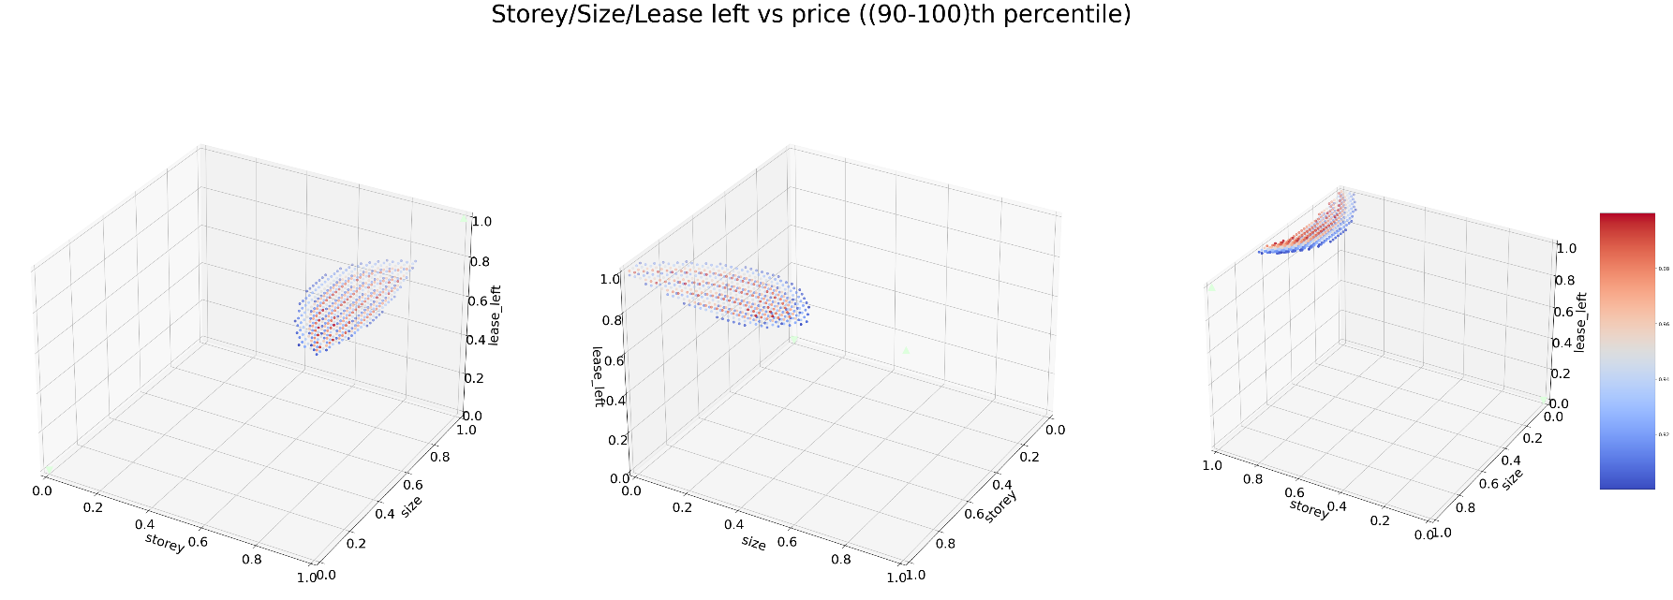

# REFERENCES

1. Hale, J. (2020, Aug 20). Which Evaluation Metric Should You Use in Machine Learning Regression Problems? Retrieved Jun 25, 2023, from <https://towardsdatascience.com/which-evaluation-metric-should-you-use-in-machine-learning-regression-problems-20cdaef258e>
2. Nau, R. (2020, Aug 18). ARIMA models for time series forecasting. *Statistical forecasting: notes on regression and time series analysis*. Retrieved Jul 12, 2023, from https://people.duke.edu/~rnau/411arim3.htm
3. Brownlee, J. (2020, Aug 15). A Gentle Introduction to the Box-Jenkins Method for Time Series Forecasting. Retrieved Jul 12, 2023, from https://machinelearningmastery.com/gentle-introduction-box-jenkins-method-time-series-forecasting/

1. Reference: https://towardsdatascience.com/which-evaluation-metric-should-you-use-in-machine-learning-regression-problems-20cdaef258e
2. Resource used to aid in this: https://people.duke.edu/~rnau/411arim3.htm
3. Resource used to aid in this: <https://machinelearningmastery.com/gentle-introduction-box-jenkins-method-time-series-forecasting/>